<https://www.youtube.com/watch?v=xxFYro8QuXA&list=PLblh5JKOoLUKxzEP5HA2d-Li7IJkHfXSe&index=4>

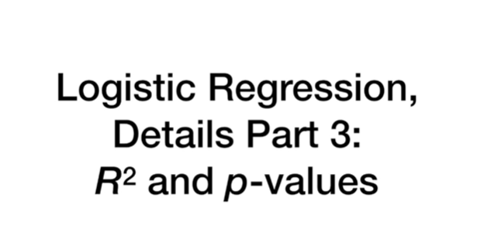

In this video we're going to continue our series on logistic regression and we're going to talk about R squared and P values.

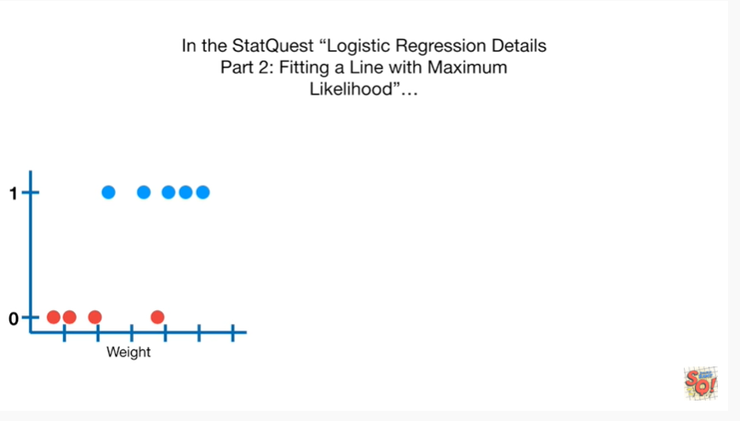

In the stat quest logistic regression details part 2 fitting a line with maximum likelihood

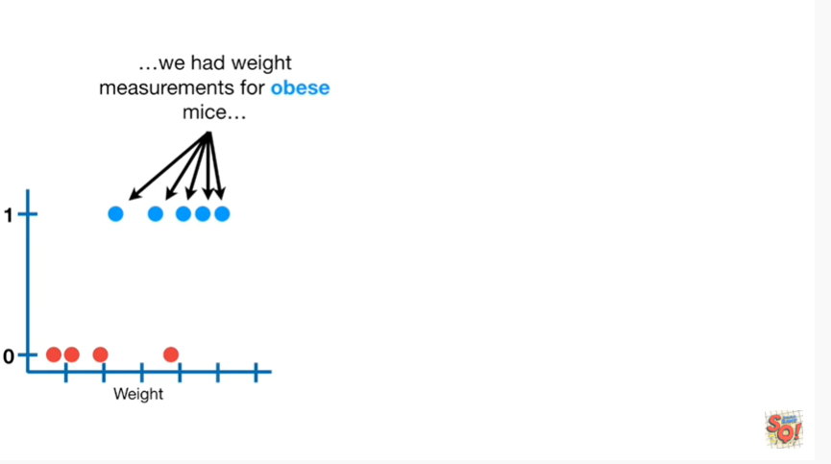

we had weight measurements for obese mice

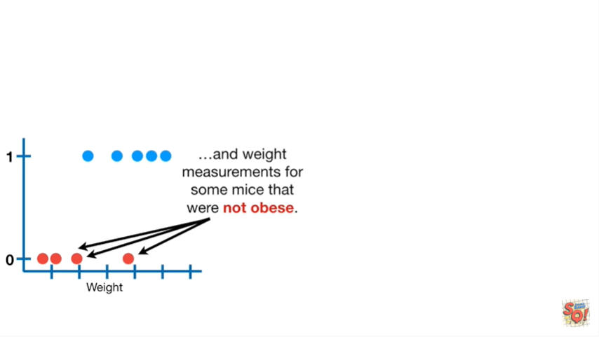

and weight measurements for some mice that were not obese

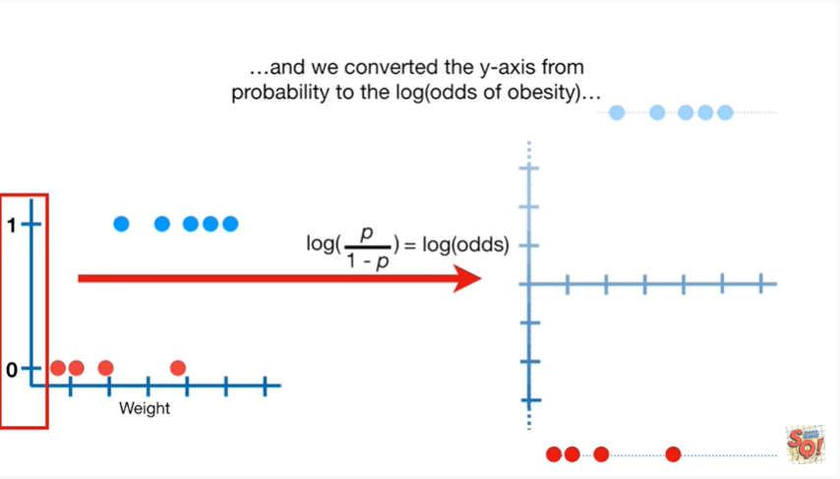

and we converted the y-axis from probability to the log odds of obesity

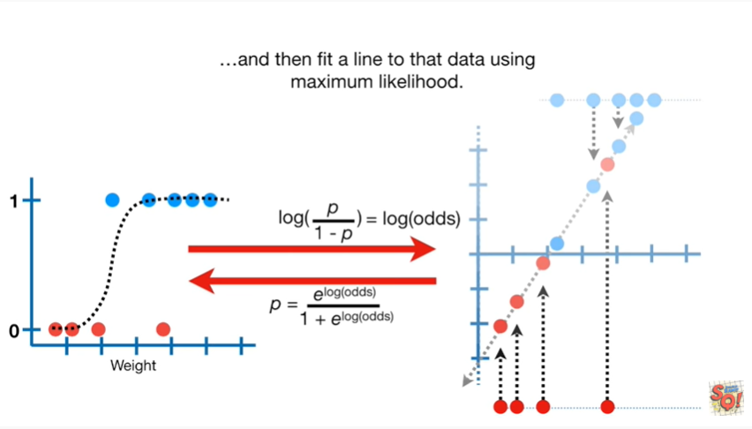

and then fit a line to that data using maximum likelihood.

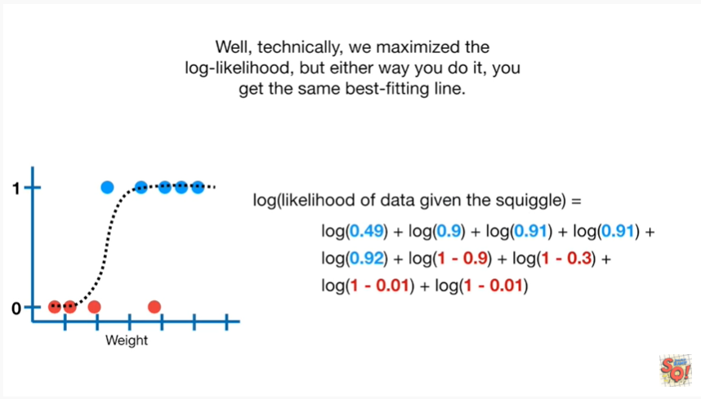

Well technically we maximize the log likelihood but either way you do it you get the same best fitting line.

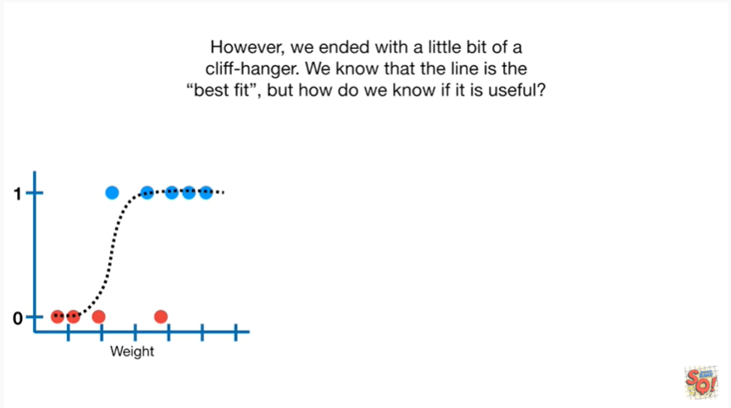

However we ended with a bit of a cliffhanger.

We know that the line is best fit, but how do we know if it is useful ?

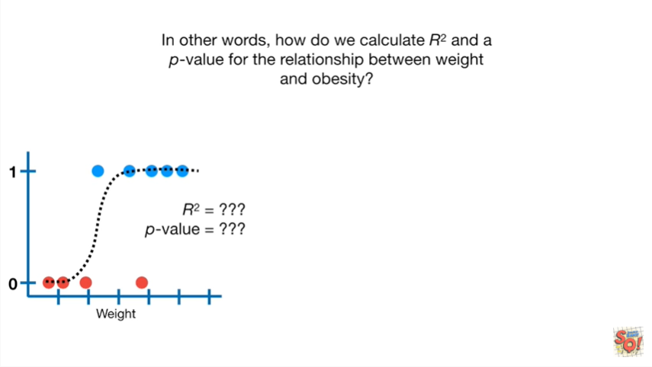

In other words how do we calculate R squared and a p-value for the relationship between weight and obesity ?

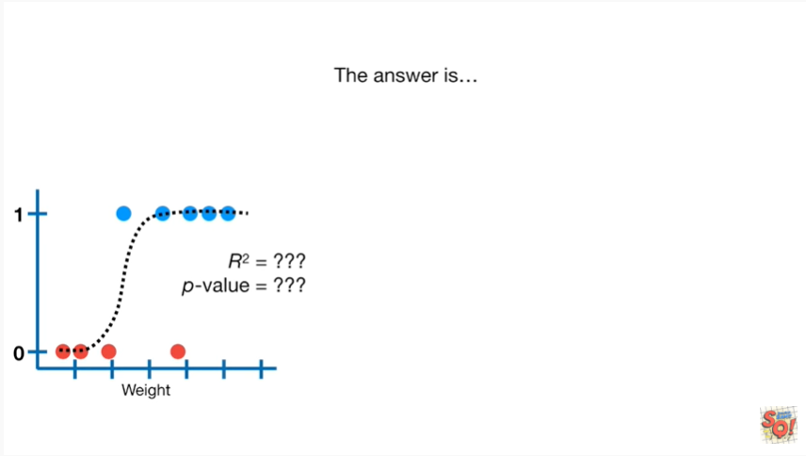

The answer is

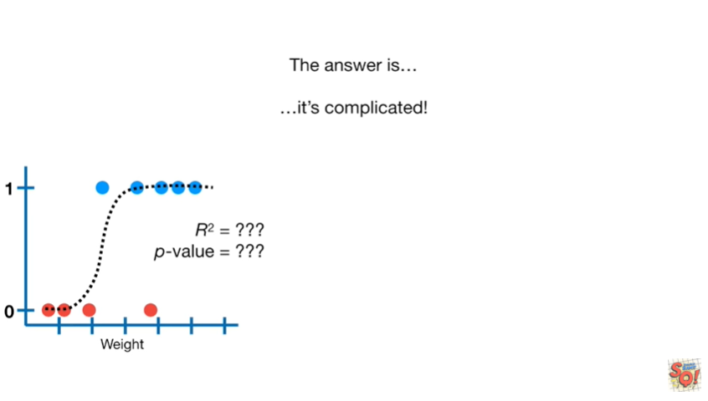

it's complicated.

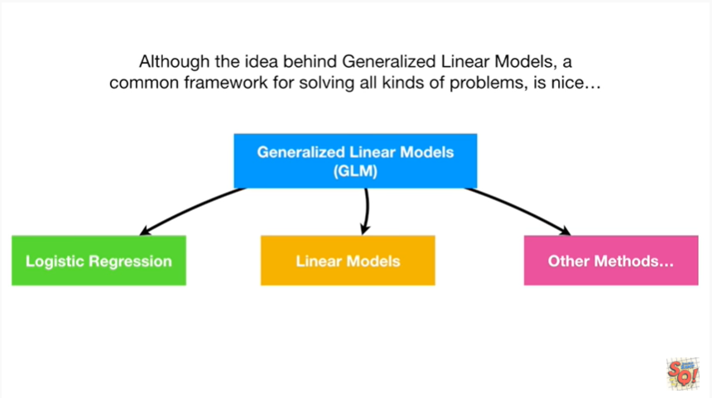

Although the idea behind generalized linear models a common framework for solving all kinds of problems is nice.

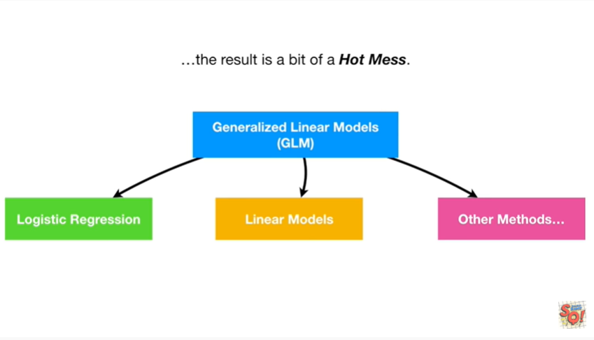

The result is a bit of a hot mess.

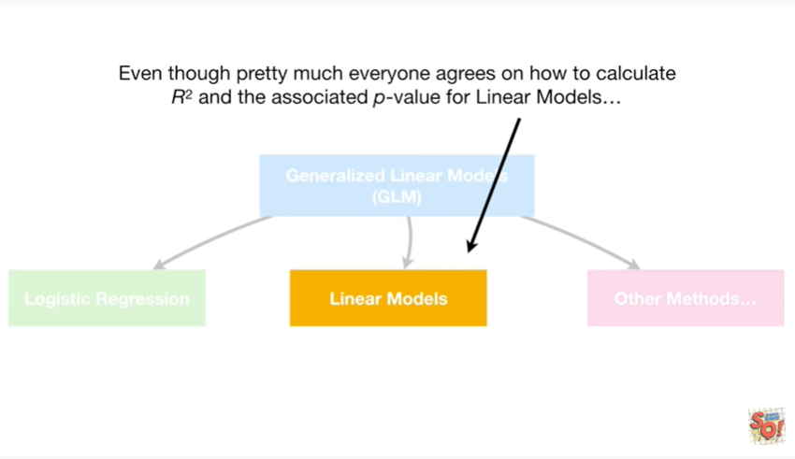

Even though pretty much everyone agrees on how to calculate R squared and The Associated p-value for linear models.

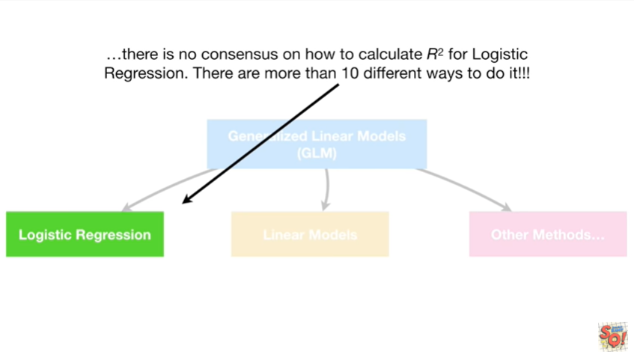

There is no consensus on how to calculate R squared for logistic regression.

There are more than 10 different ways to do it.

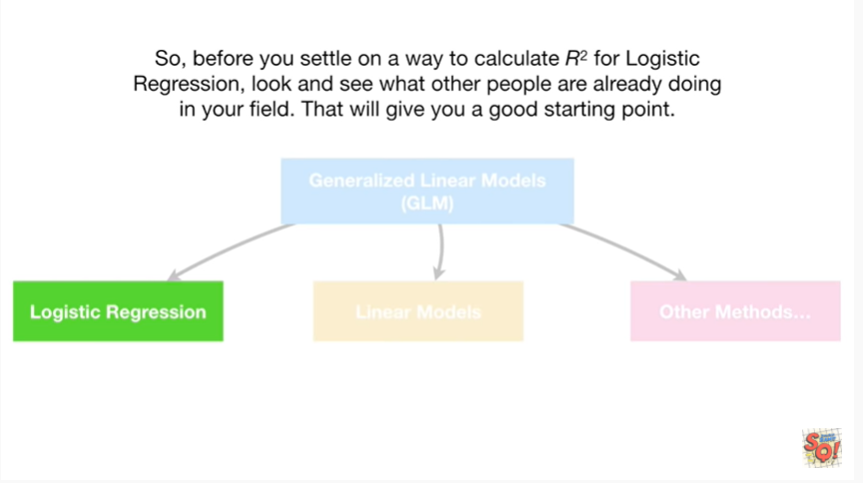

So before you settle on a way to calculate R squared for logistic regression, look and see what other people are already doing in your field that will give you a good starting point.

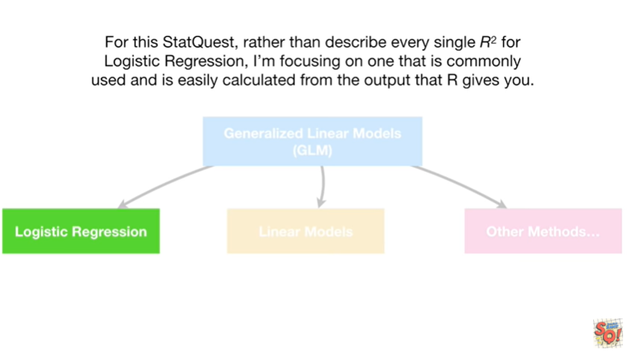

For this stat quest rather than describe every single r-squared for logistic regression, I'm focusing on one that is commonly used and is easily calculated from the output that R gives you.

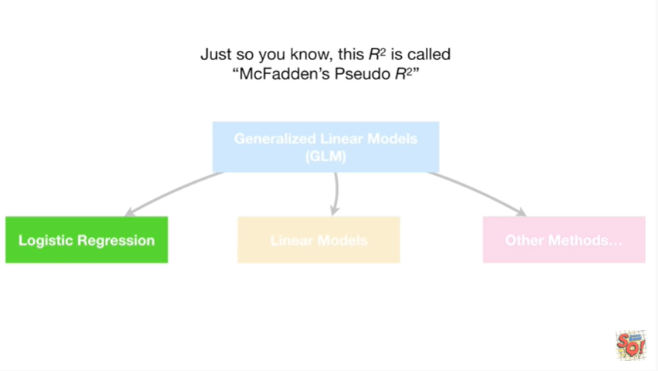

Just so you know this R squared is called McFadden's pseudo R squared.

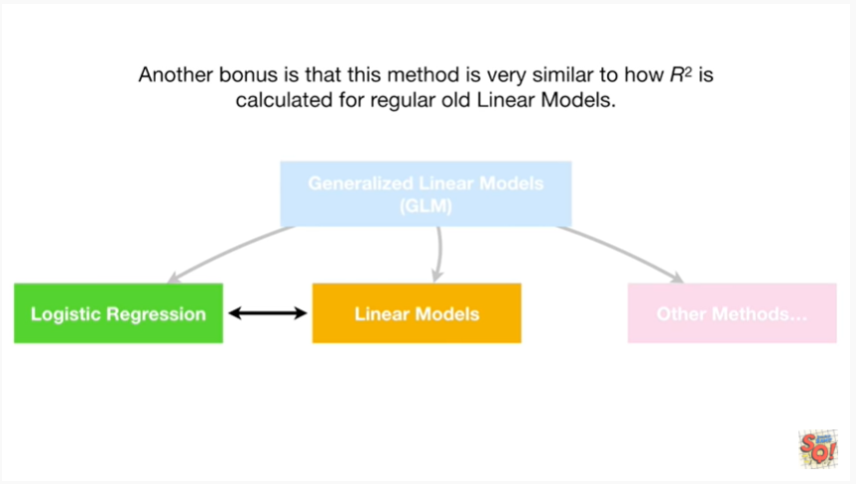

Another bonus is that this method is very similar to how R squared is calculated for regular old linear models.

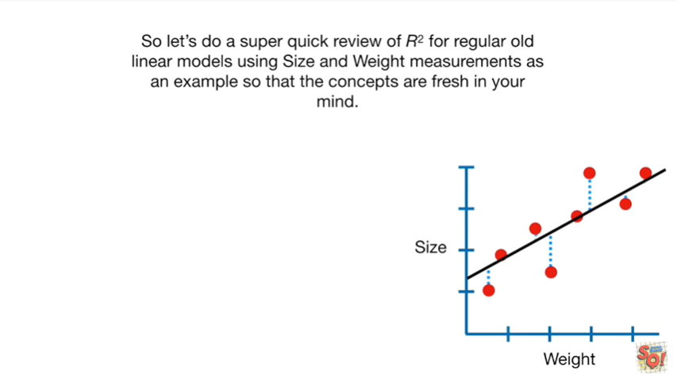

So let's do a super quick review of R squared for regular old linear models using size and weight measurements as an example so that the concepts are fresh in your mind.

Wow that was a long sentence.

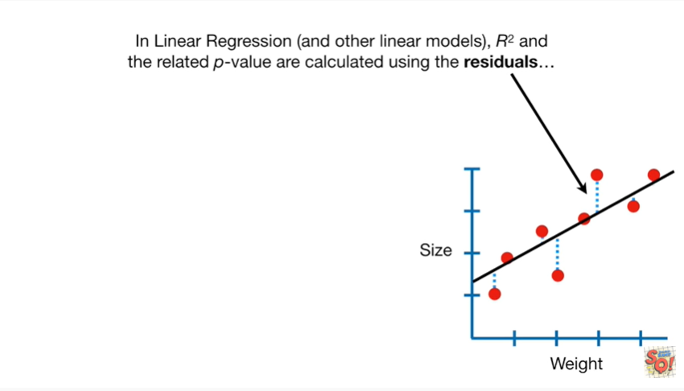

In linear regression and other linear models R squared and the related p-value are calculated using the residuals.

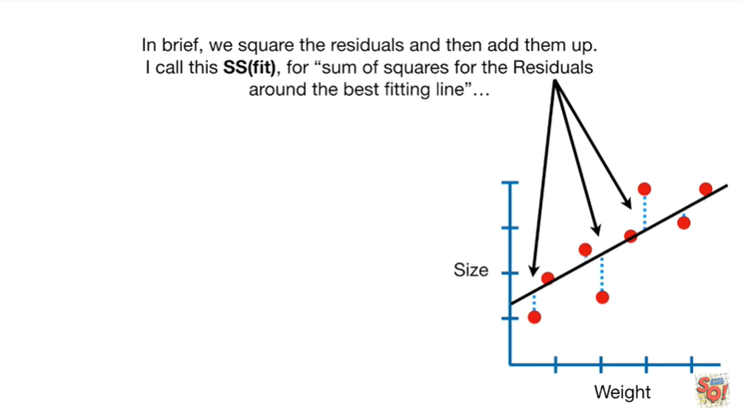

In brief we square the residuals and then add them up.

I call this SS fit for sum of squares of the residuals around the best fitting line.

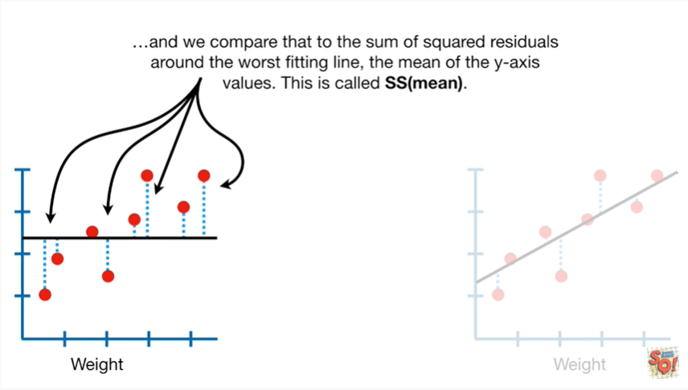

And we compare that to the sum of squared residuals around the worst fitting line, the mean of the y axis values.

This is called SS mean.

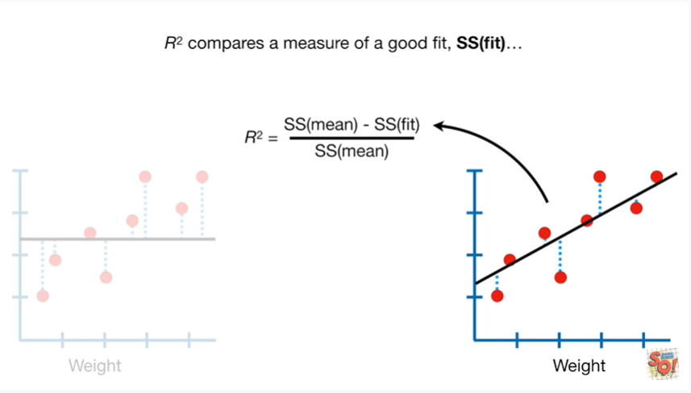

R squared compares a measure of a good fit, SS fit

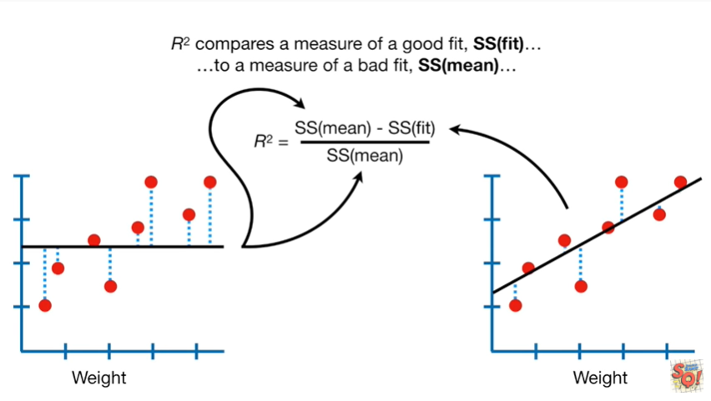

to a measure of a bad fit, SS mean.

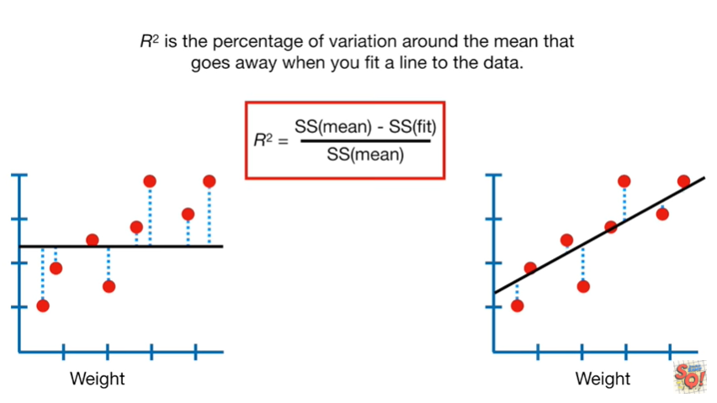

R squared is the percentage of variation around the mean that goes away when you fit a line to the data.

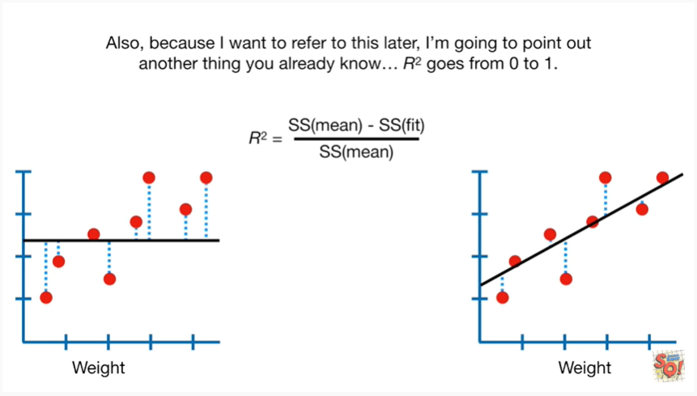

Also because I want to refer to this later I'm going to point out another thing you already know, R squared goes from 0 to 1.

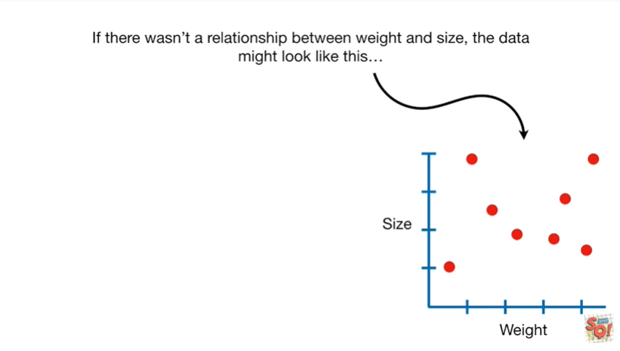

If there wasn't a relationship between weight and size the data might look like this

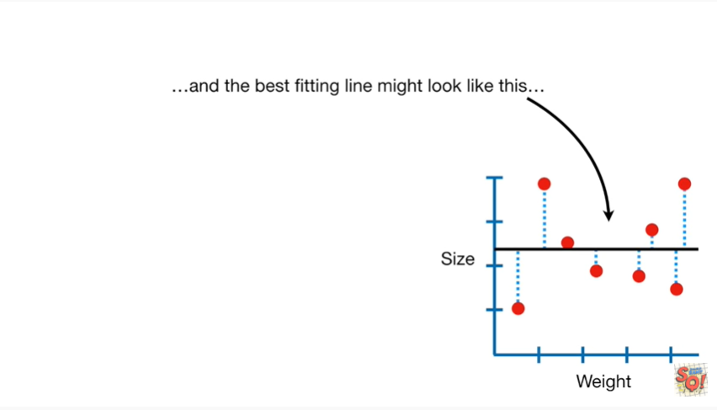

and the best fitting line might look like this.

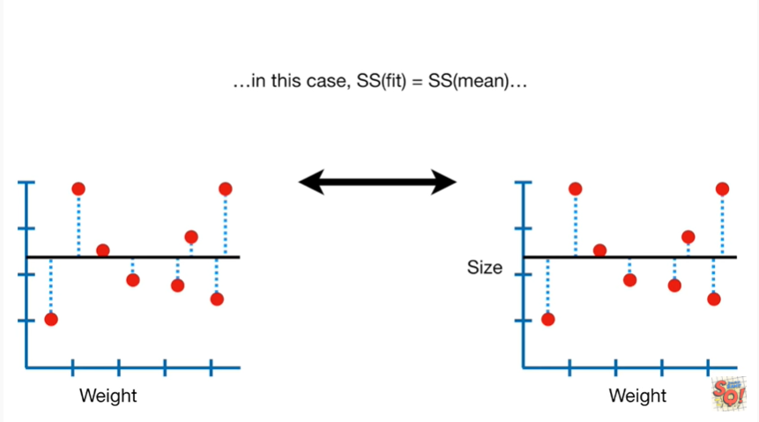

In this case SS fit equals SS mean.

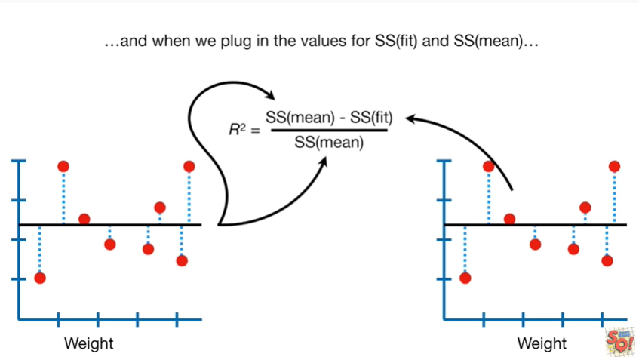

And when we plug in the values for SS fit and SS mean

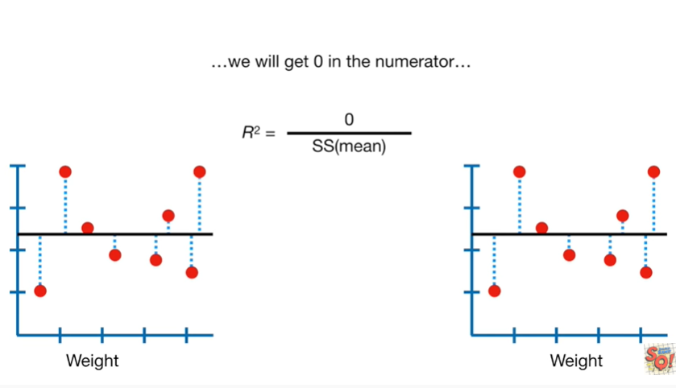

we get 0 in the numerator

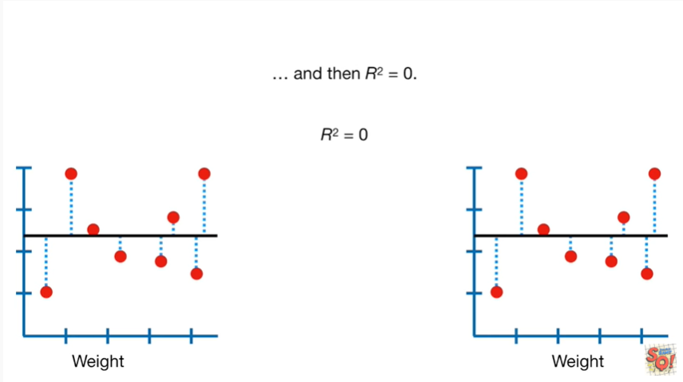

and then R squared equals 0.

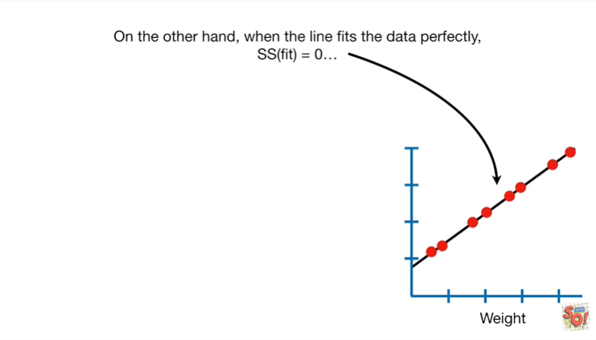

On the other hand when the line fits the data perfectly ss fit equals zero

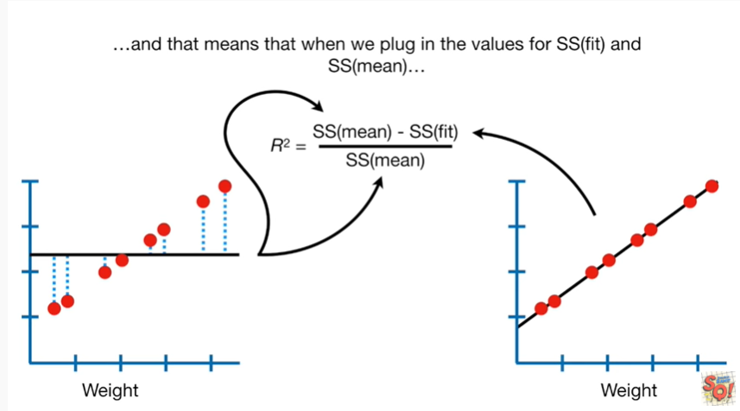

and that means when we plug in the values for SS fit and SS mean

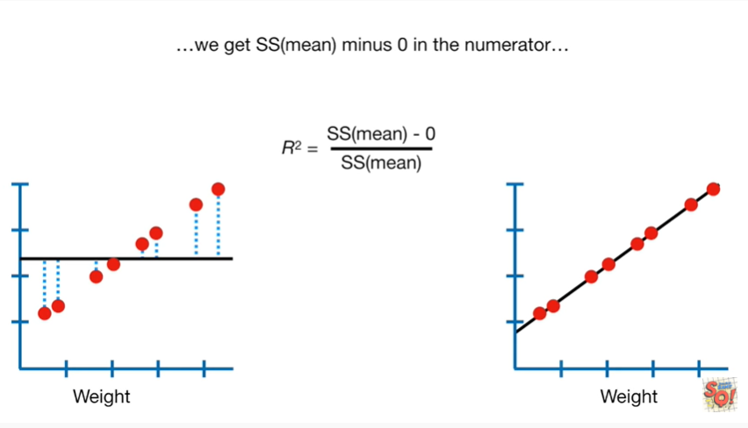

we get SS mean minus zero in the numerator

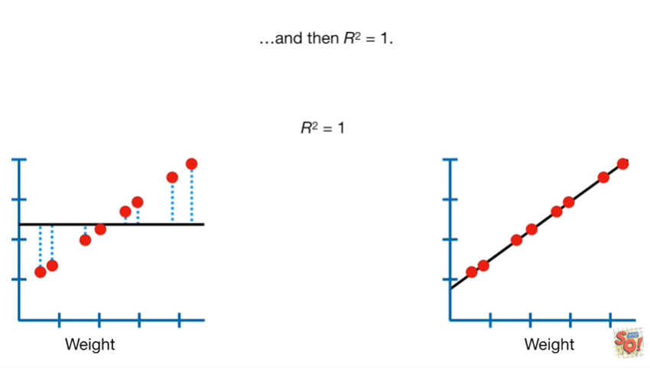

and then R squared equals one.

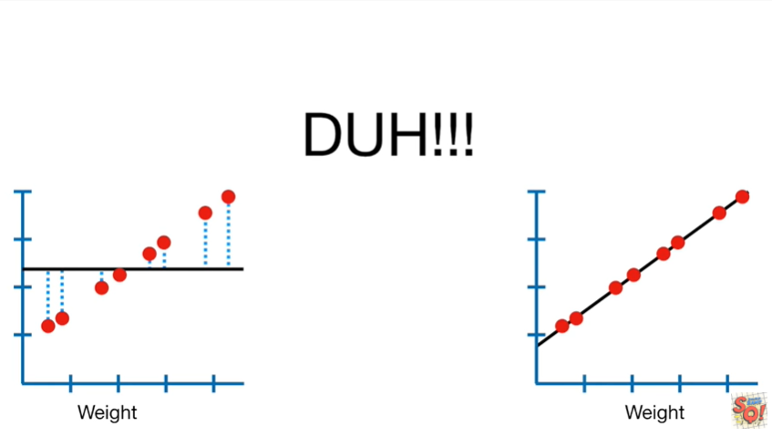

Duh !!!

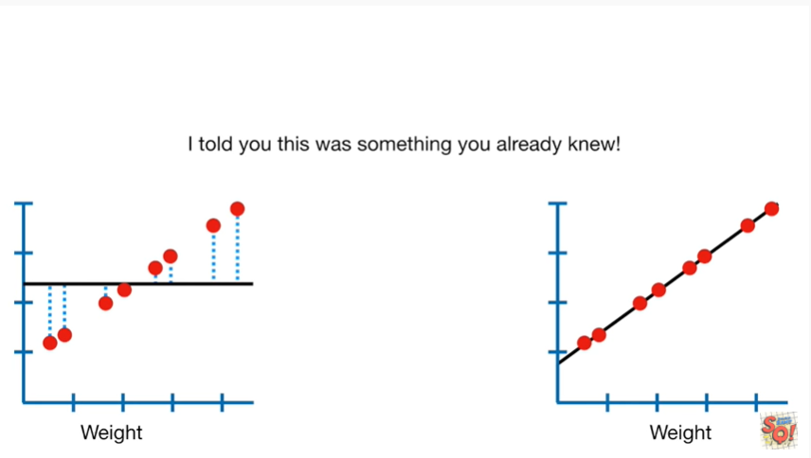

I told you this was something you already knew.

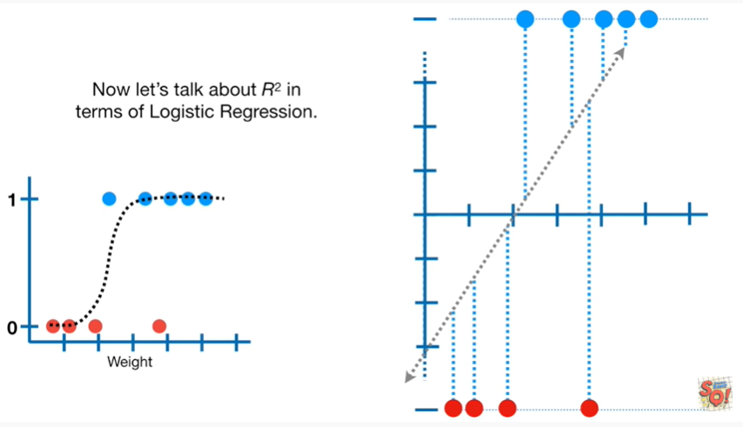

Now let's talk about R squared in terms of logistic regression.

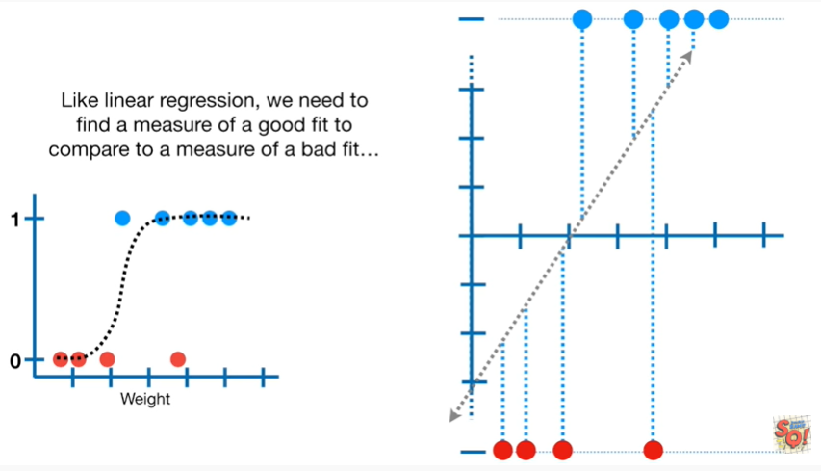

Like linear regression we need to find a measure of a good fit to compare to a measure of a bad fit.

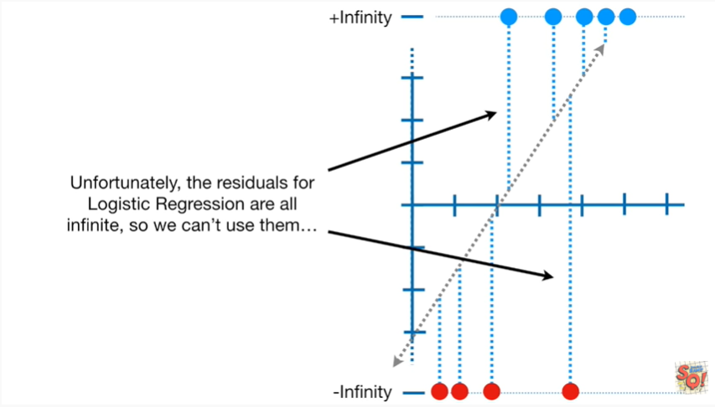

Unfortunately the residuals for logistic regression are all infinite so we can't use them

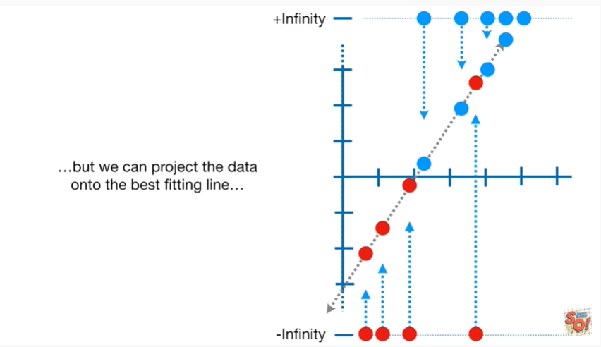

but we can project the data onto the best fitting line

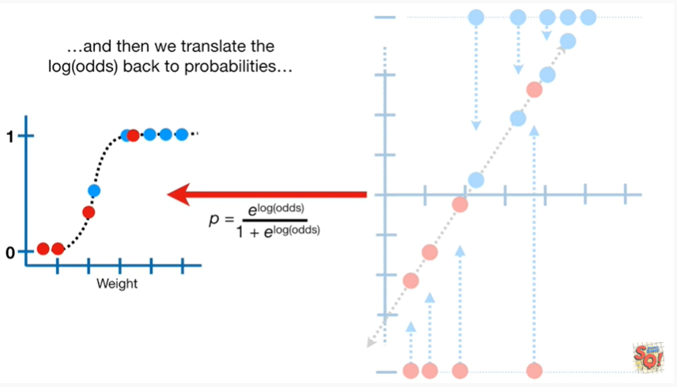

and then we translate the log odds back to probabilities

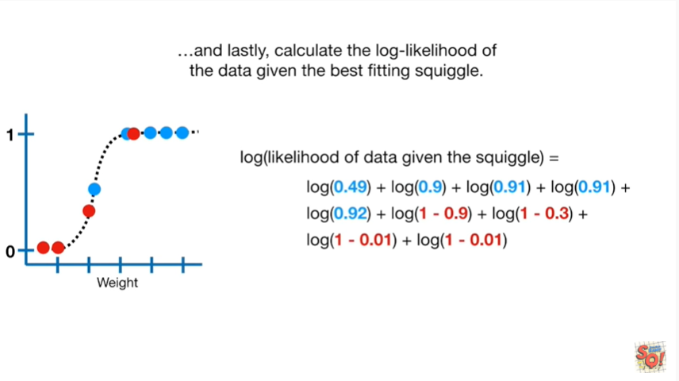

and lastly calculate the log likelihood of the data given the best fitting squiggle.

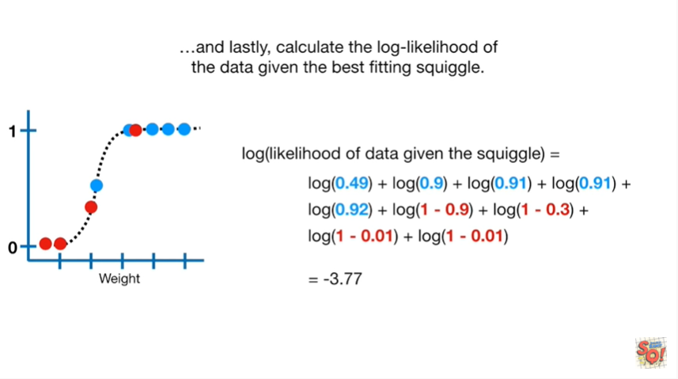

In this case that gives us negative three point seven seven.

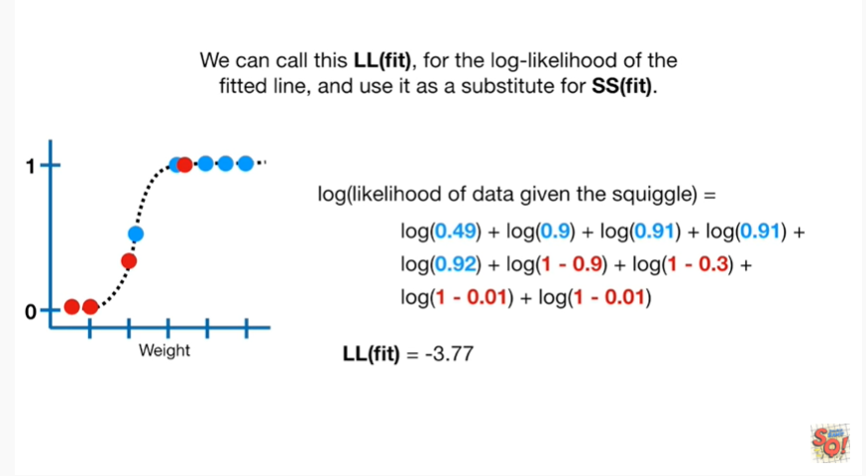

We can call this LL(fit) for the log likelihood of the fitted line and use it as a substitute for SS fit.

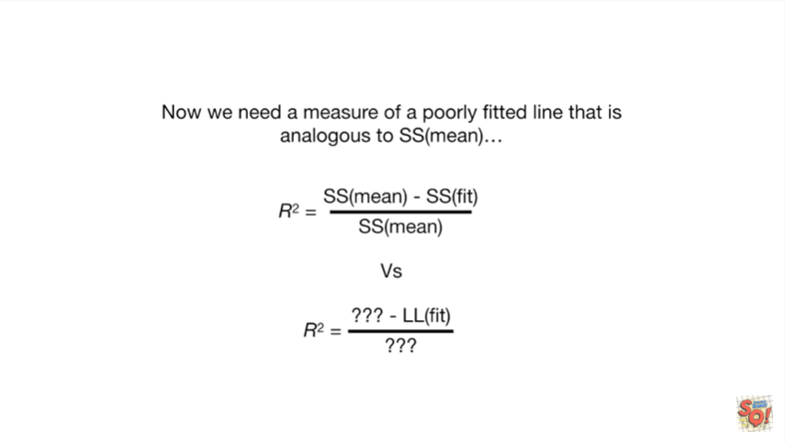

Now we need a measure of a poorly fitted line that is analogous to SS mean.

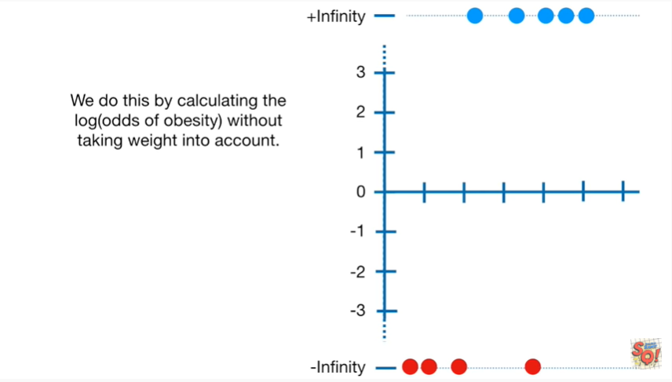

We do this by calculating the log odds of obesity without taking weight into account.

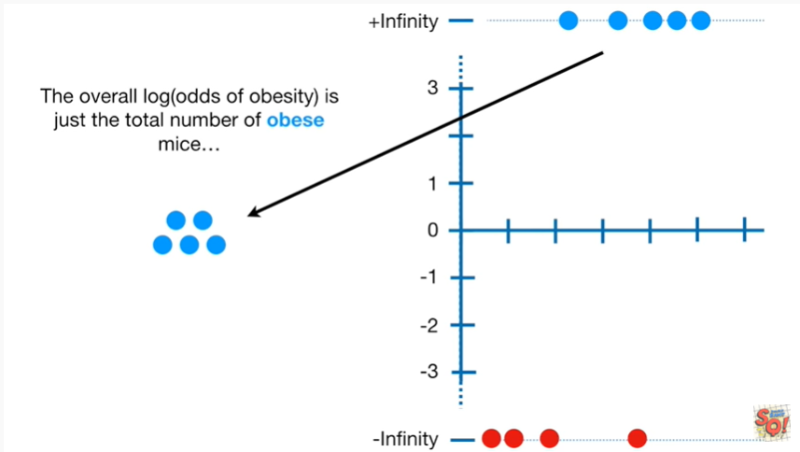

The overall log odds of obesity is just the total number of obese mice

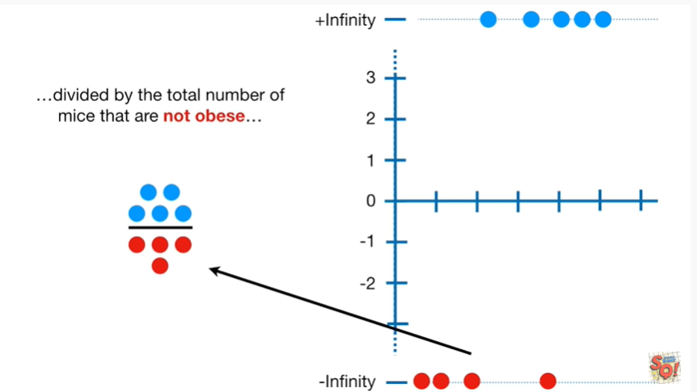

divided by the total number of mice that are not obese

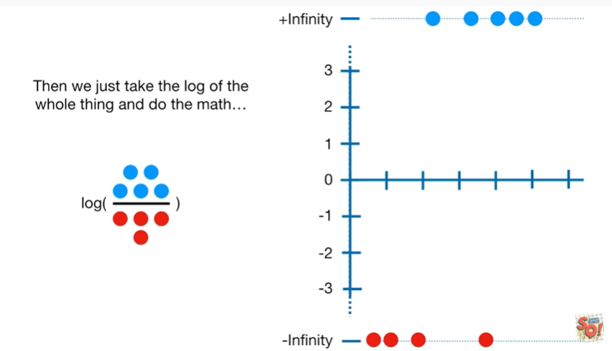

then we just take the log of the whole thing and do the math

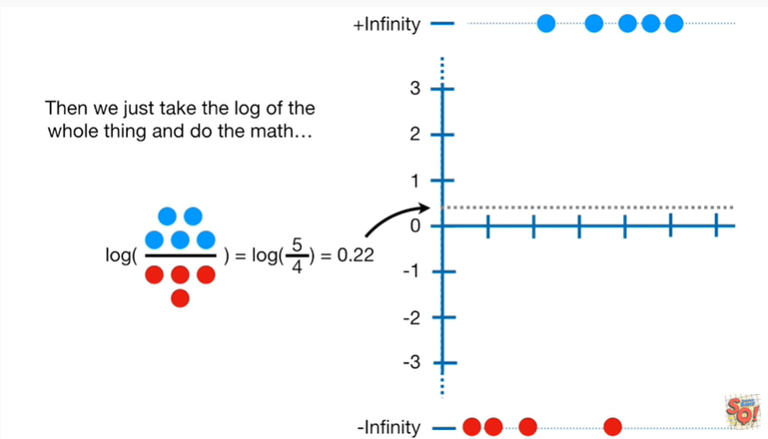

in this case we get a horizontal line at zero point two two

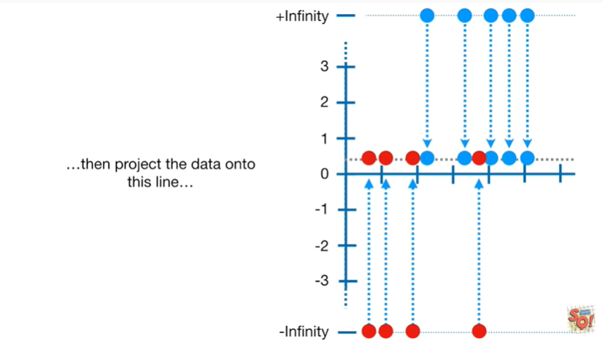

then project the data onto this line

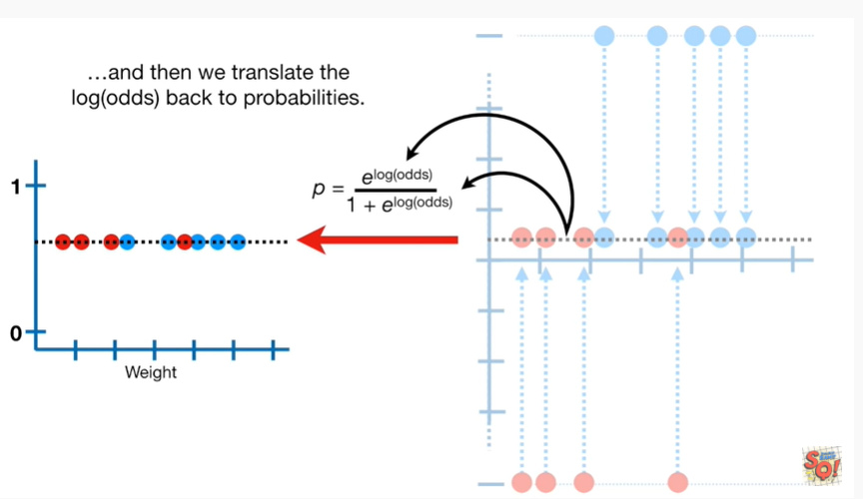

and then we translate the log odds back to probabilities

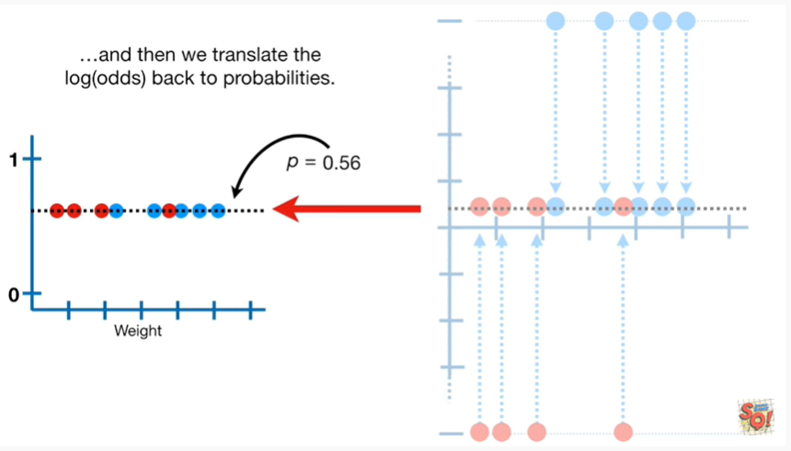

that gives us a horizontal line at P equals zero point five six.

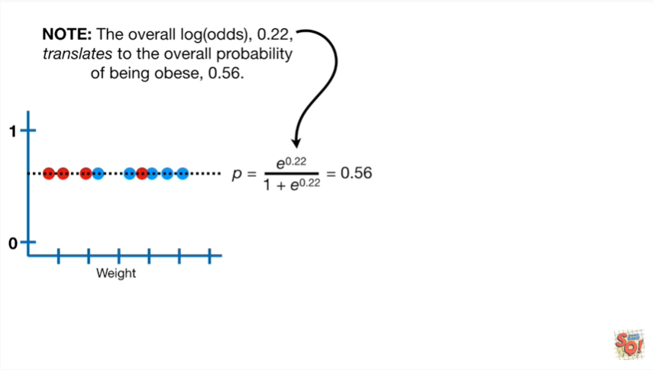

Note : the overall log odds zero point two two translates to the overall probability of being obese zero point five six.

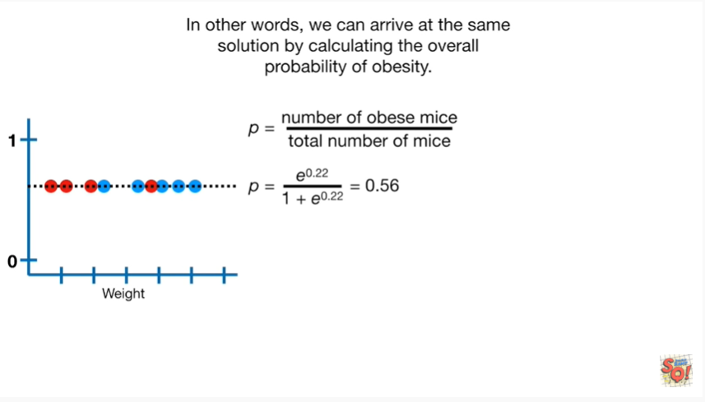

In other words we can arrive at the same solution by calculating the overall probability of obesity.

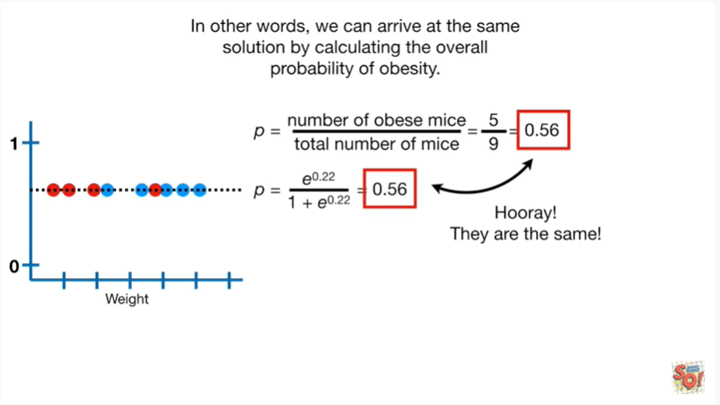

Hooray they are the same.

So we have two different ways to calculate the exact same number.

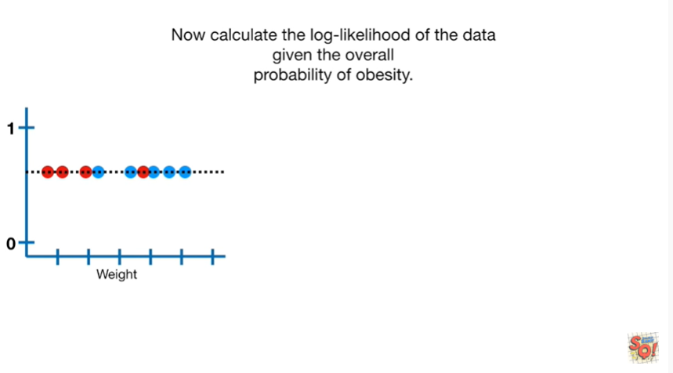

Now calculate the log likelihood of the data given the overall probability of obesity

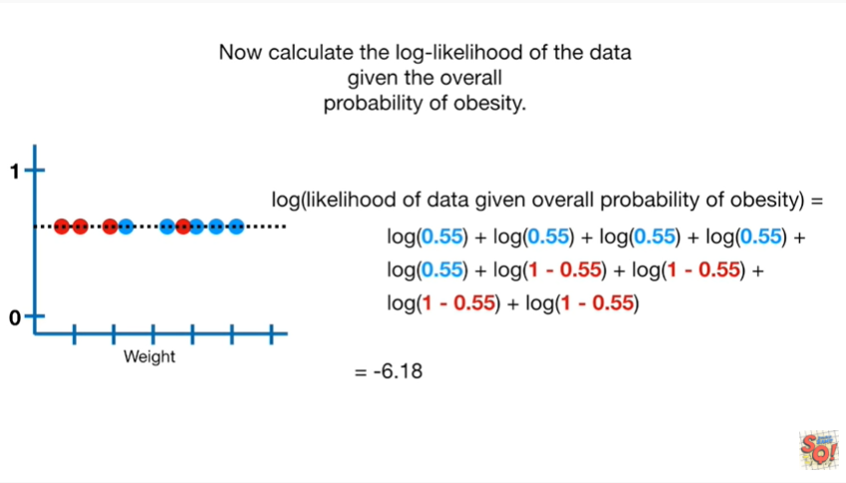

this gives us negative six point one eight.

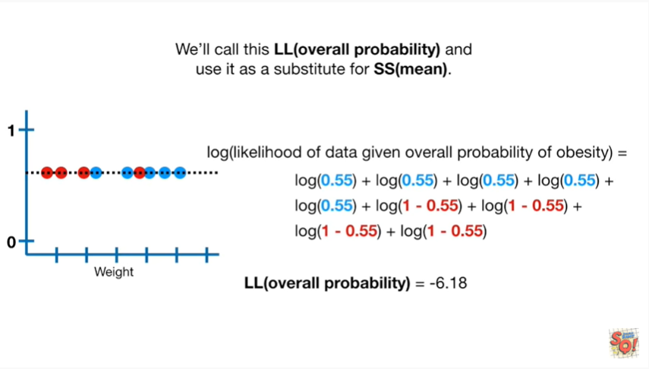

We'll call this ll overall probability and use it as a substitute for SS mean.

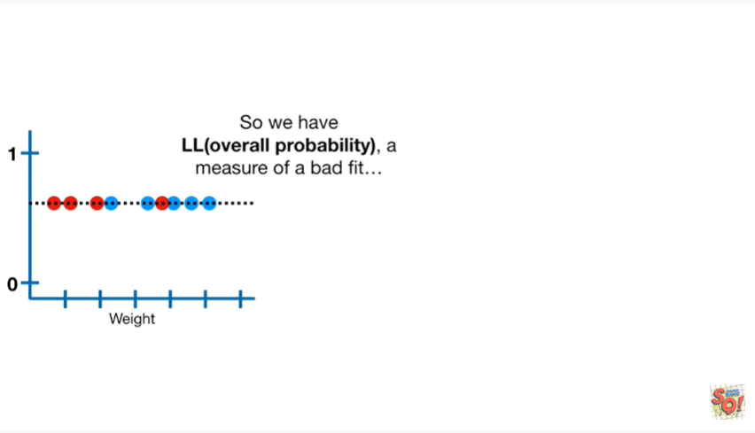

So we have LL overall probability a measure of a bad fit

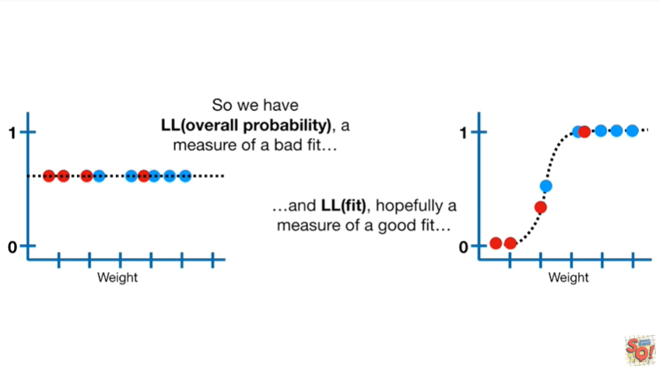

and LL(fit) hopefully a measure of a good fit

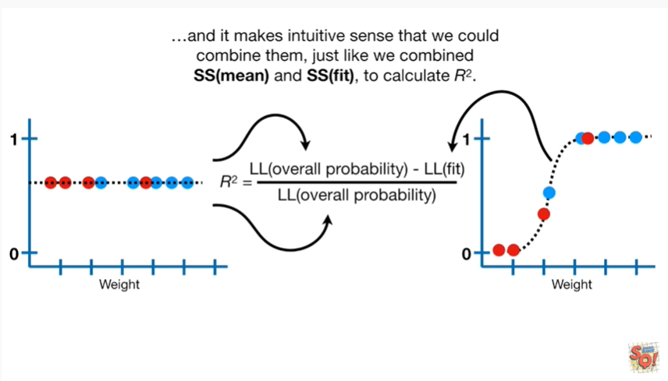

and it makes intuitive sense that we could combine them just like we combined SS mean and SS fit to calculate R squared.

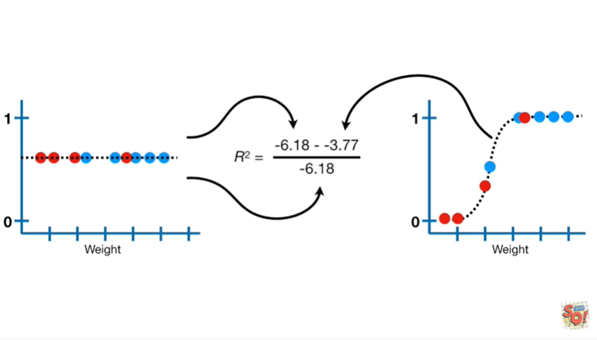

plugging in the numbers

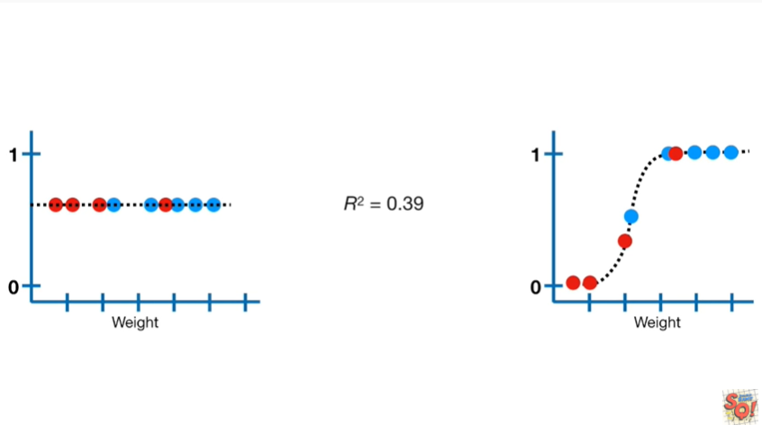

gives us an r-squared value equals zero point three nine.

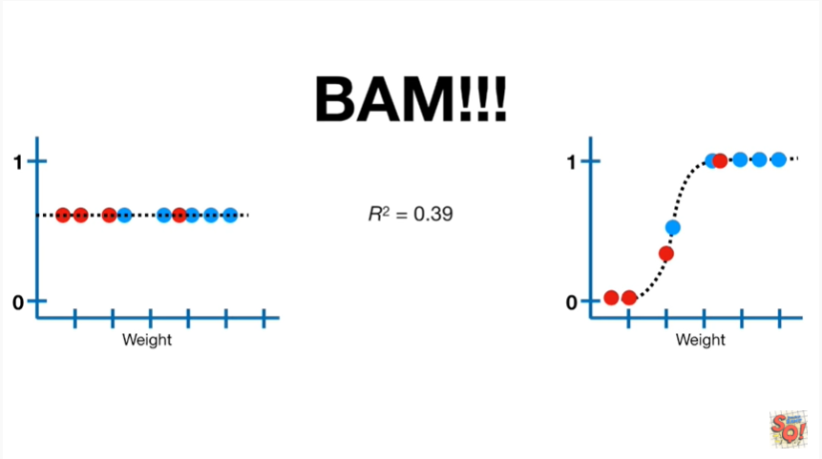

BAM !!!

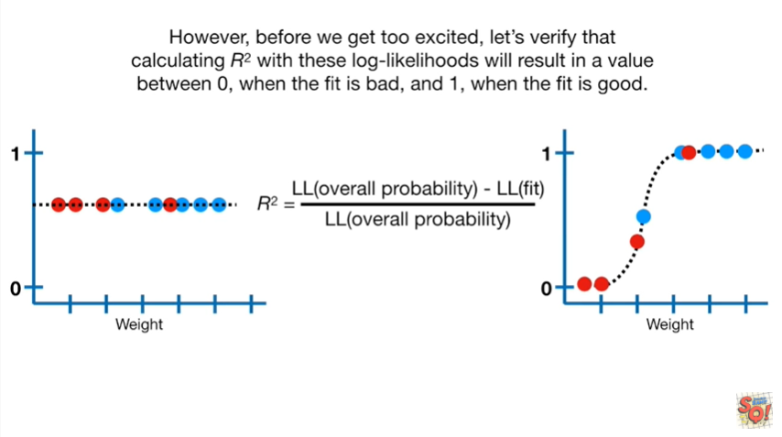

However before we get too excited, let's verify that calculating R squared with these log likelihoods will result in a value between zero when the fit is bad and one when the fit is good.

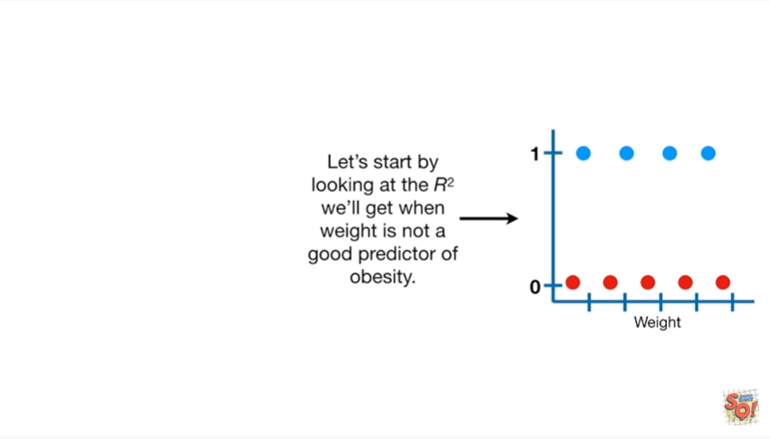

Let's start by looking at the r-squared we'll get when weight is not a good predictor of obesity.

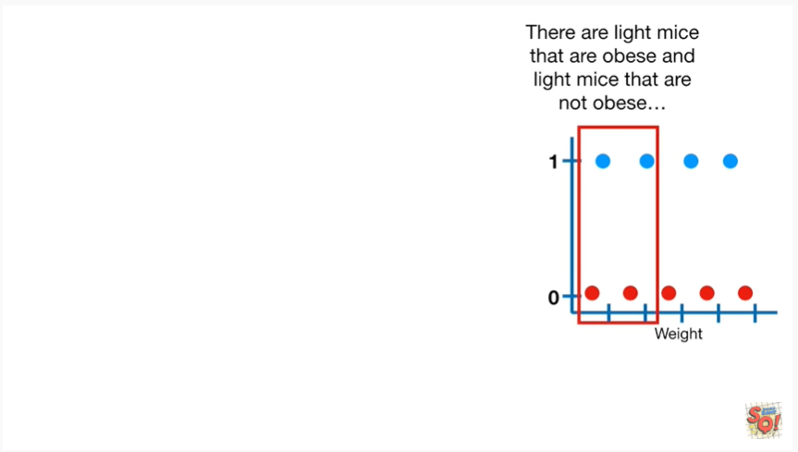

There are light mice that are obese and light mice that are not obese

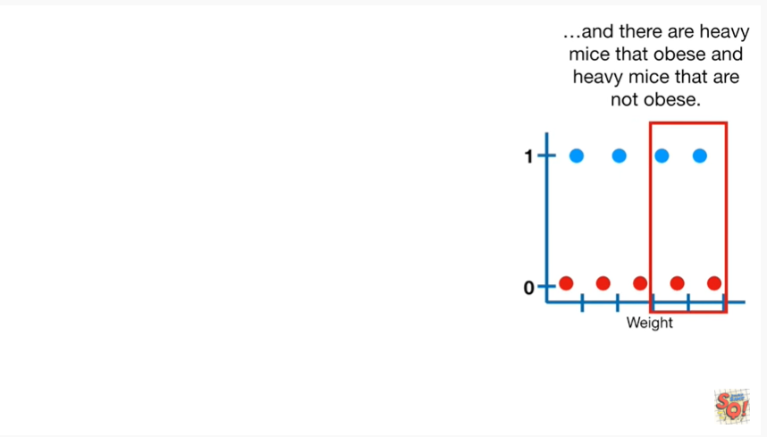

and there are heavy mice that are obese and heavy mice that are not obese.

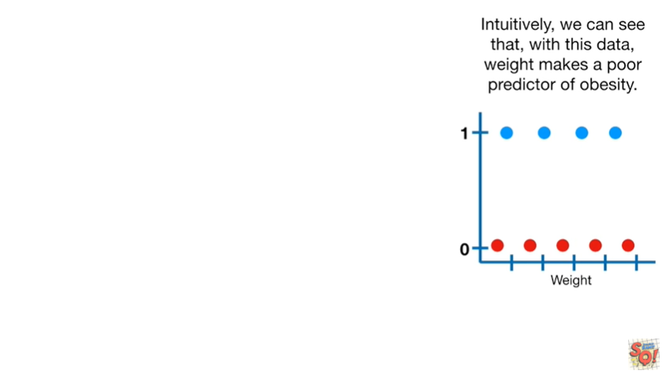

Intuitively we can see that with this data weight makes a poor predictor of obesity.

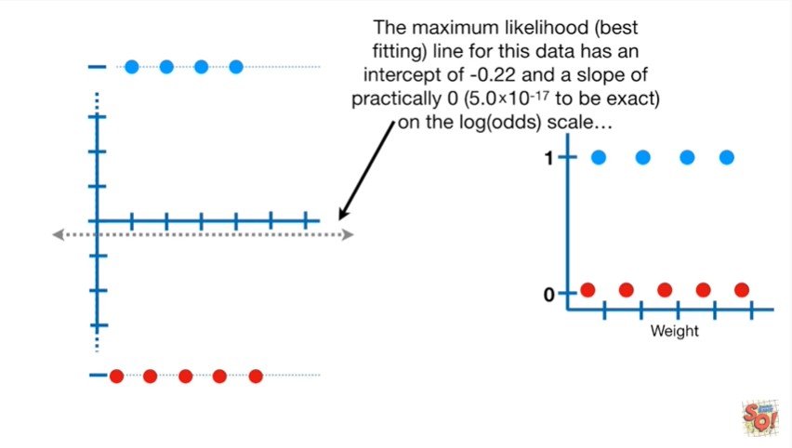

The maximum likelihood best fitting line for this data has an intercept of negative zero point two two and a slope of practically zero 5.10 to the negative 17 to be exact on the log-odds scale.

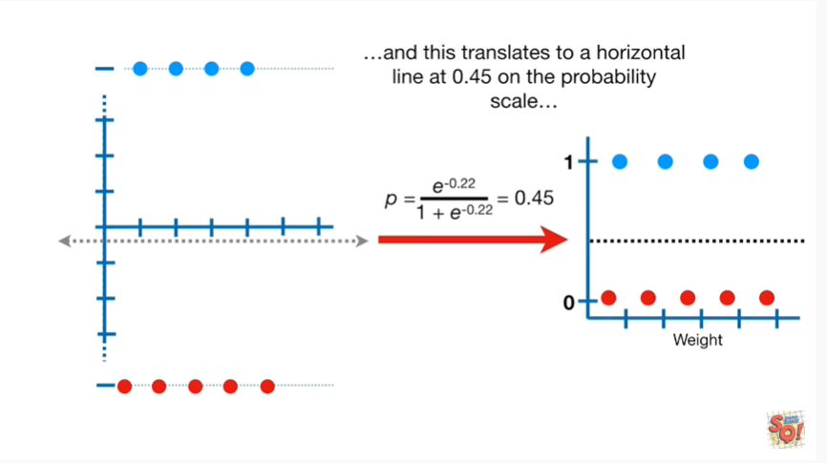

And this translates to a horizontal line at 0.45 on the probability scale.

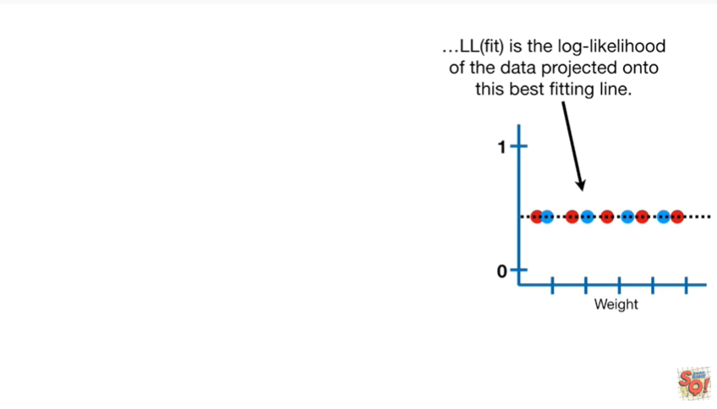

LL(fit) is the log likelihood of the data projected onto the best fitting line

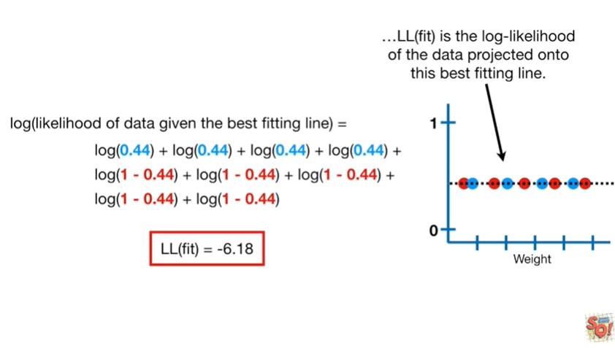

and that value is negative six point one eight.

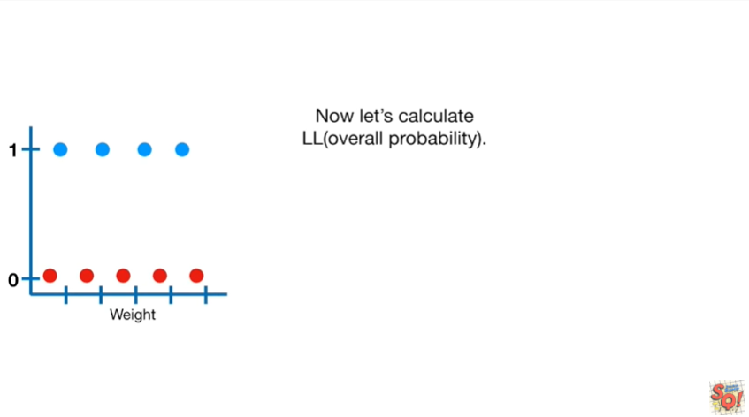

Now let's calculate ll overall probability.

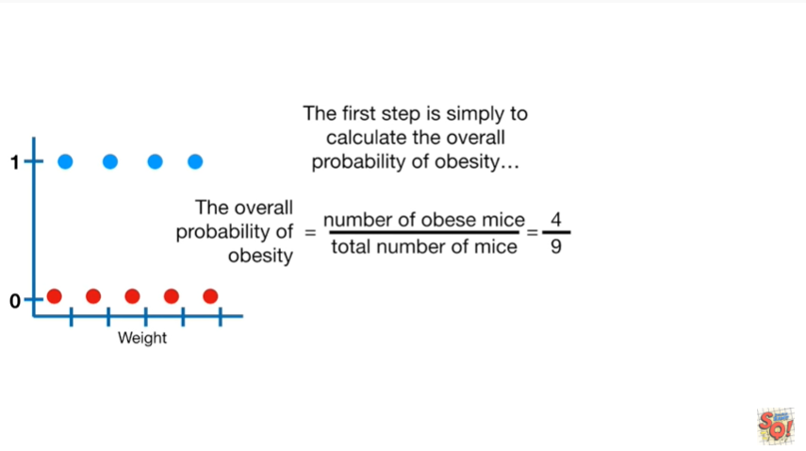

The first step is simply to calculate the overall probability of obesity.

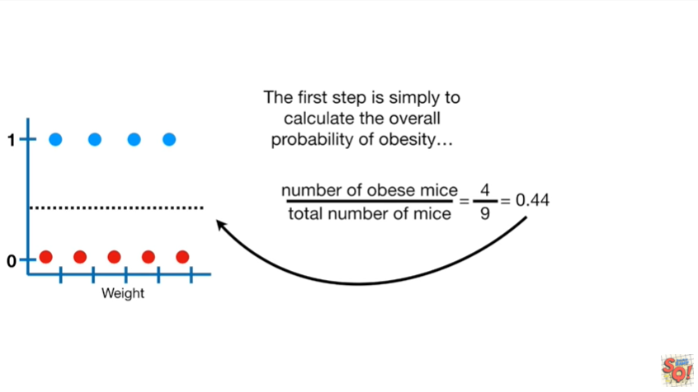

That gives us a line at zero point four four.

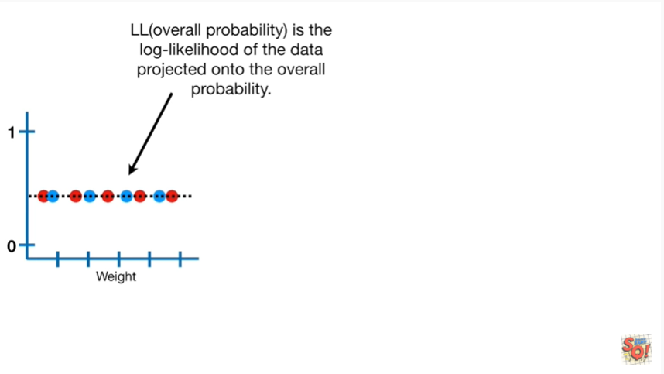

LL(overall probability) is the log likelihood of the data projected onto the overall probability.

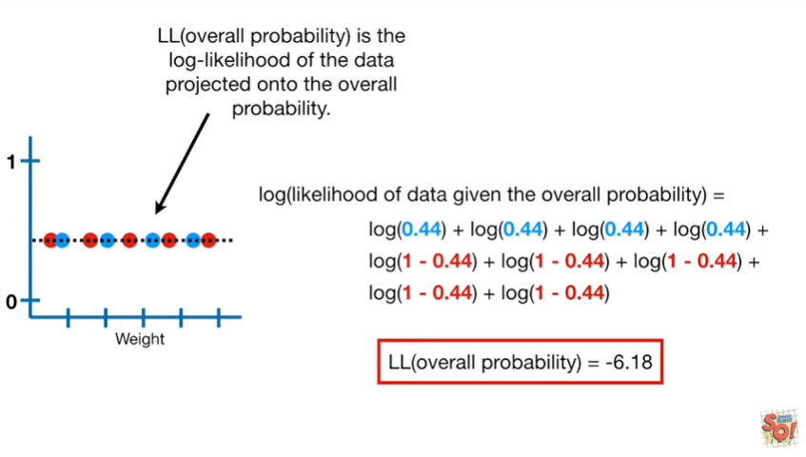

In this case LL(overall probability) equals negative six point one eight.

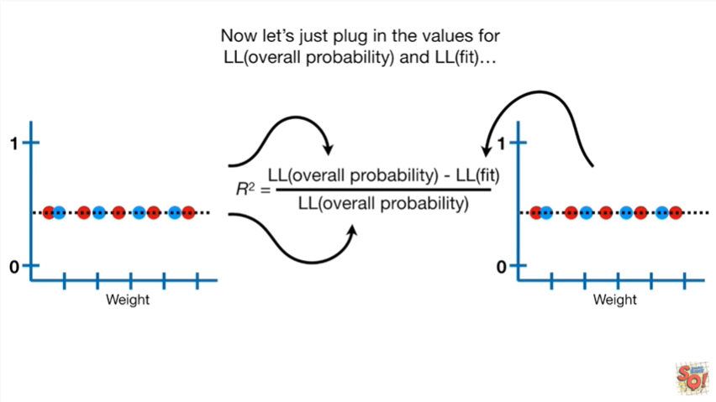

Now let's just plug in the values for LL(overall probability) and LL(fit)

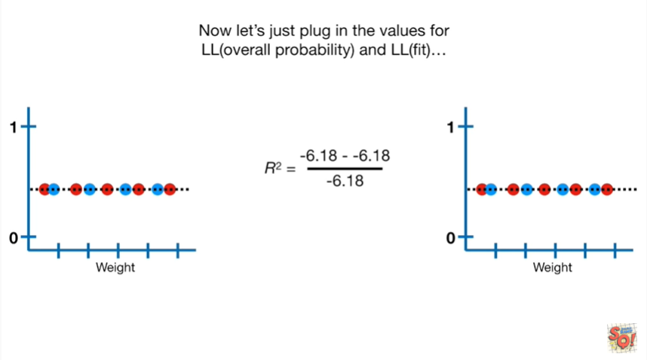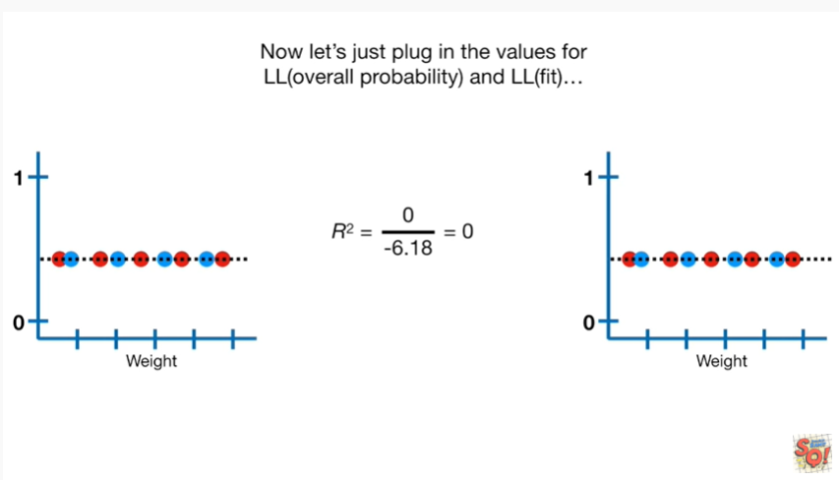

when we do the math we get R squared equals zero.

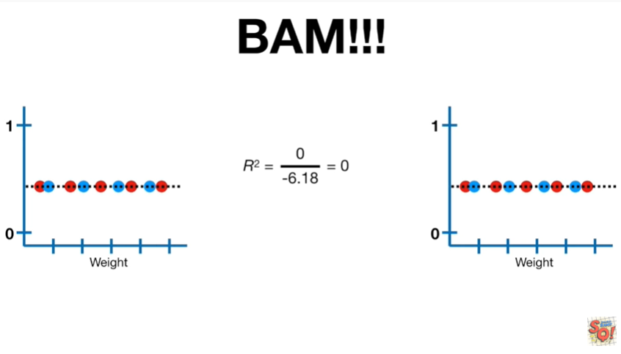

BAM !!!

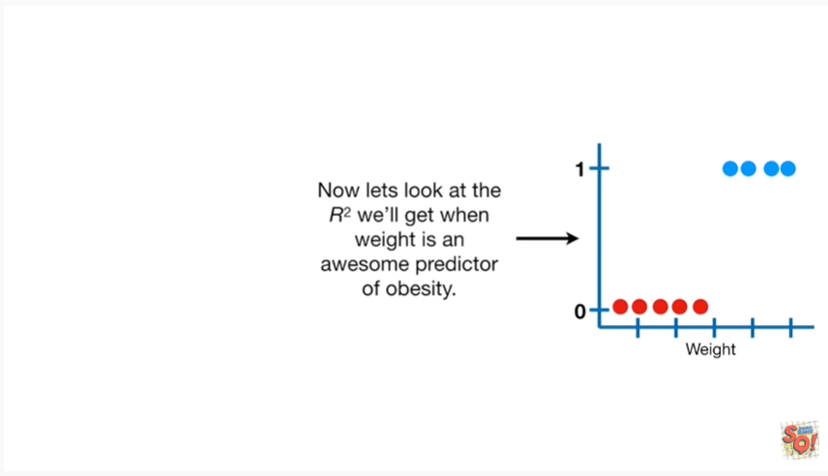

Now let's look at the R squared we'll get when weight is an awesome predictor of obesity.

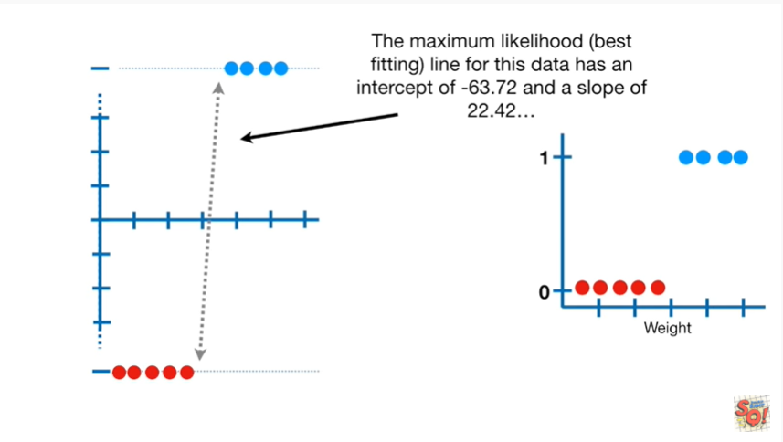

The maximum-likelihood best fitting line for this data has an intercept of negative sixty three point seven two and a slope of twenty two point four two.

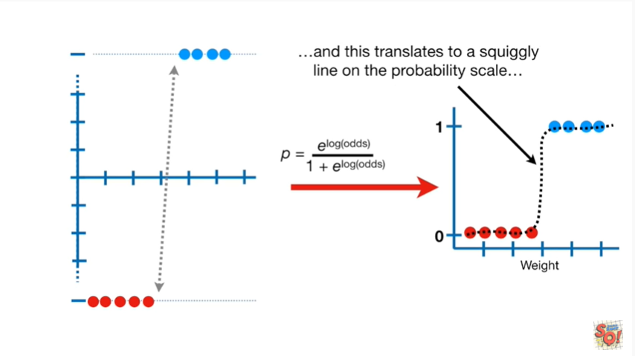

And this translates to a squiggly line on the probability scale.

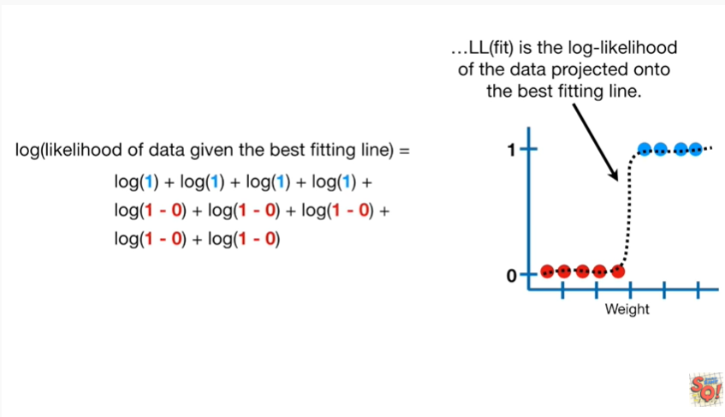

LL(fit) is the log likelihood of the data projected onto the best fitting line.

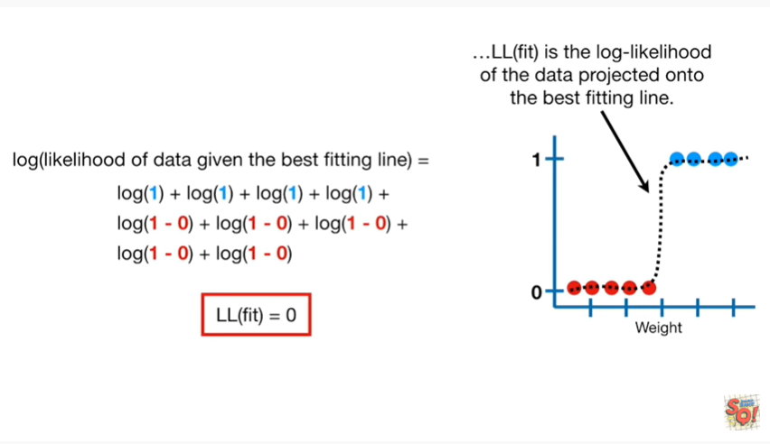

In this case LL(fit) equals zero.

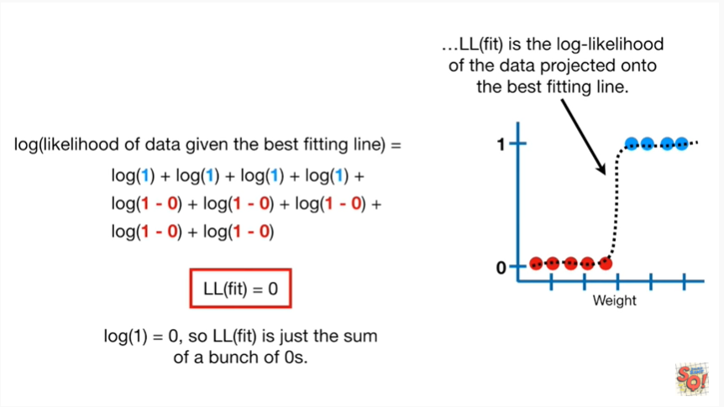

That's because the log of one equals zero so LL(fit) is just the sum of a bunch of zeros.

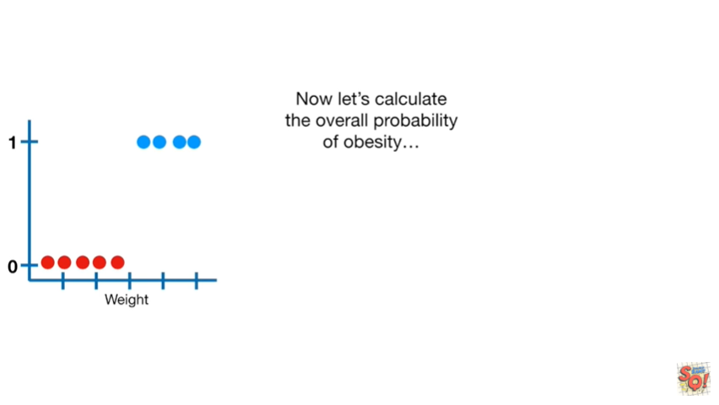

Now let's calculate the overall probability of obesity

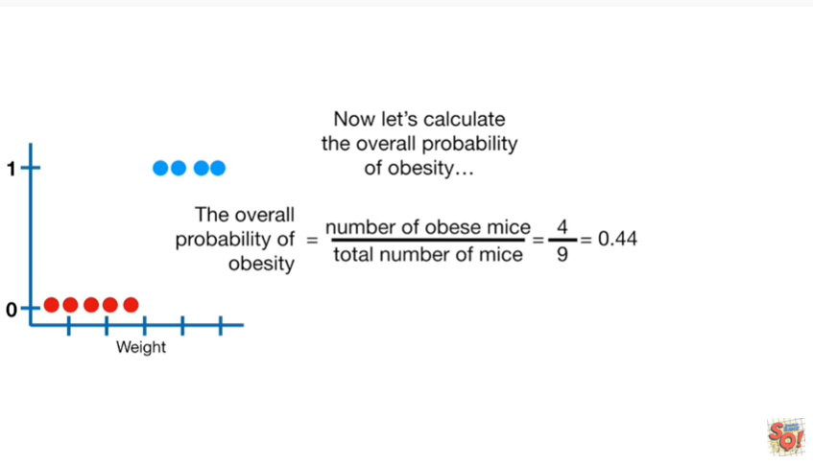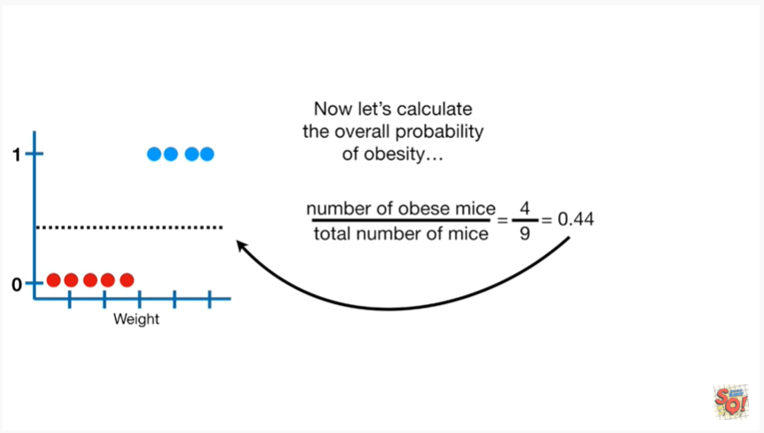

and that gives us a line at 0.44.

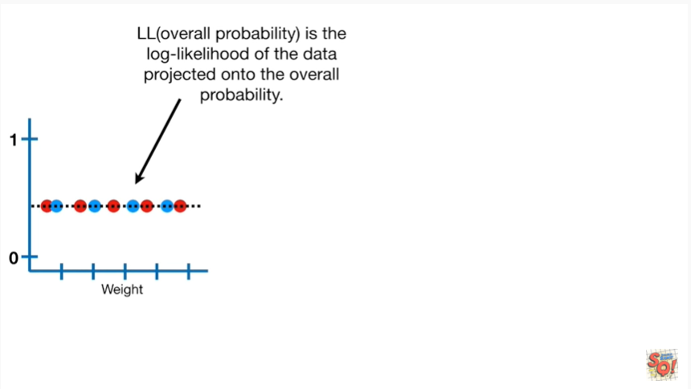

LL(overall probability) is the log likelihood of the data projected onto the overall probability.

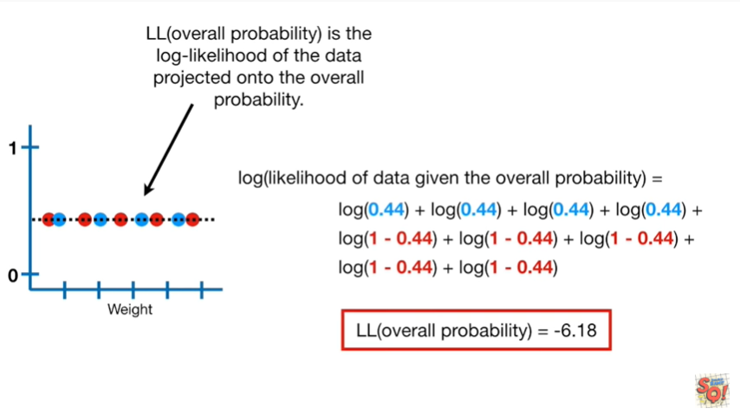

In this case that value is negative six point one eight.

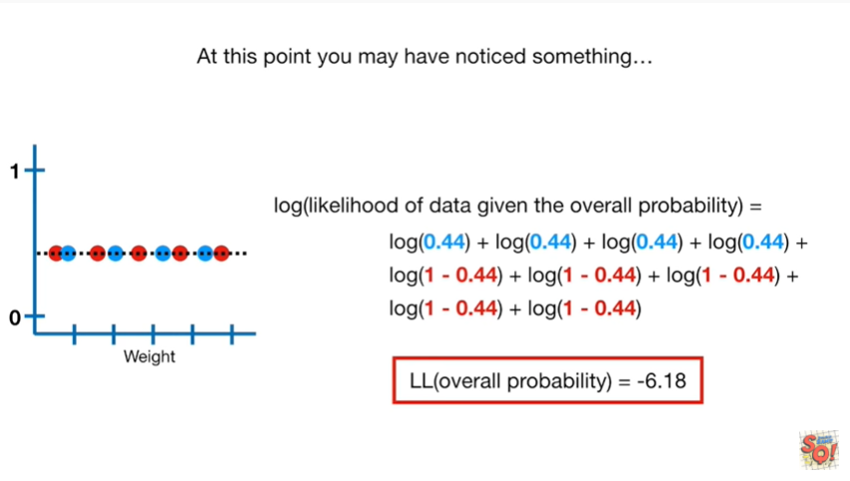

At this point you may have noticed something.

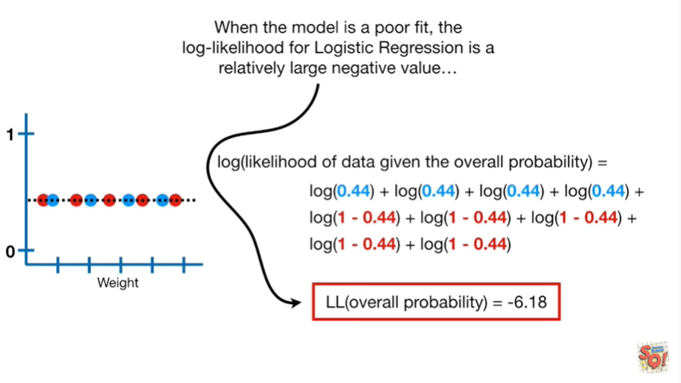

When the model is a poor fit, the log likelihood for logistic regression is a relatively large negative value.

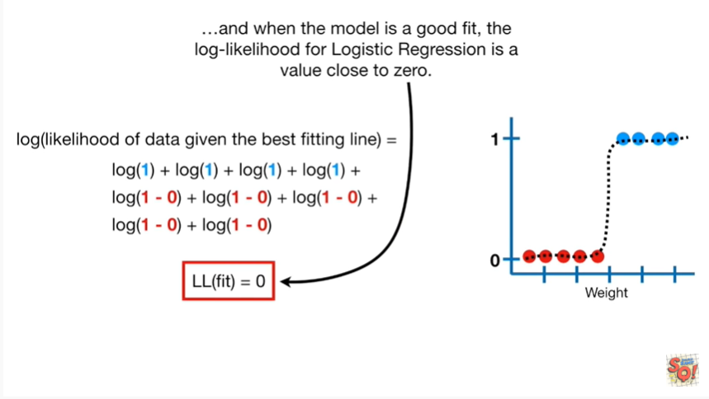

And when the model is a good fit the log likelihood for logistic regression is a value close to zero.

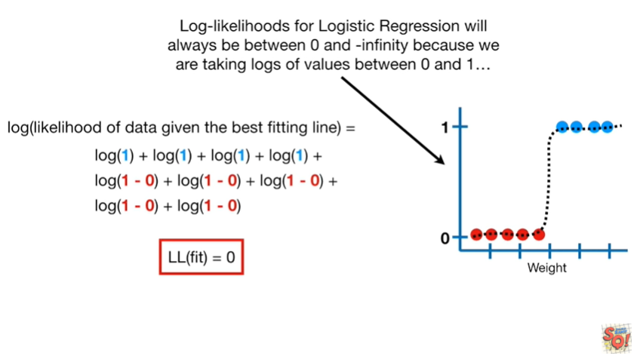

Log likelihoods for logistic regression will always be between zero and negative infinity because we are taking logs of values between 0 and 1.

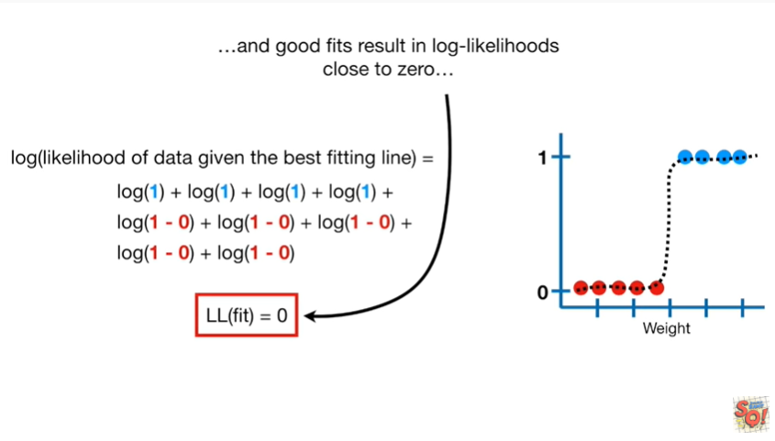

And good fits result in log likelihoods close to 0

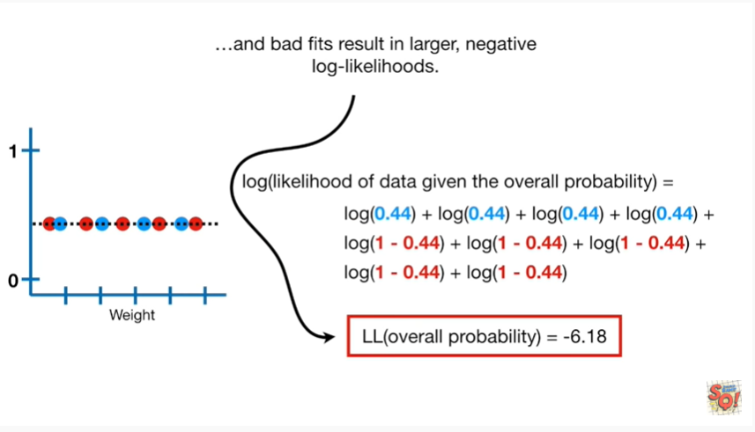

and bad fits result in larger negative log likelihoods.

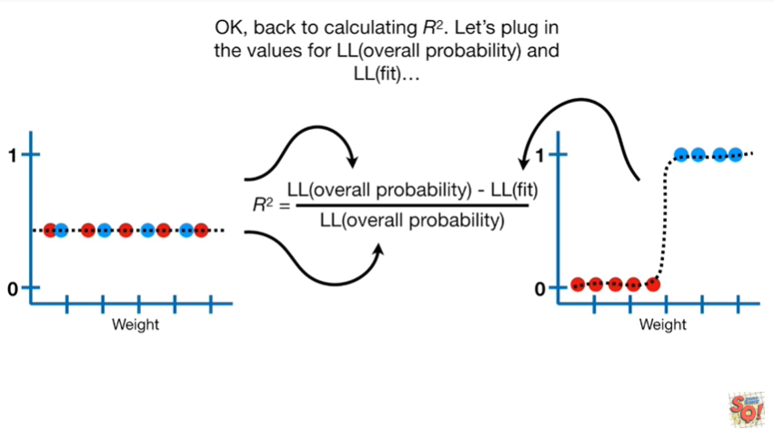

Okay back to calculating r squared.

Let's plug in the values for LL(overall probability and LL(fit)

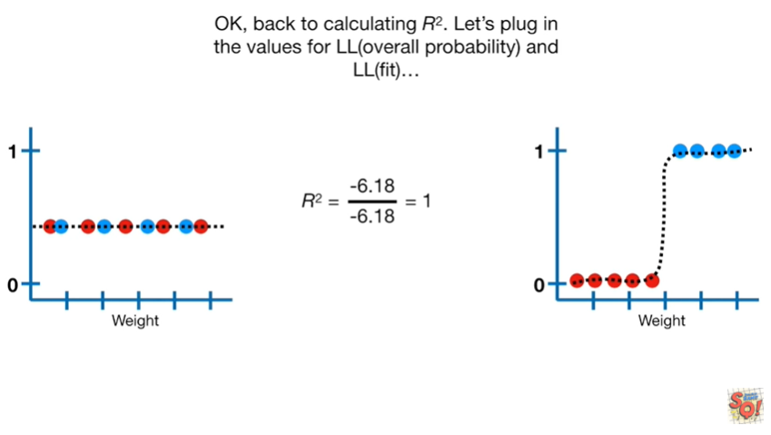

this gives us an R squared equals 1.

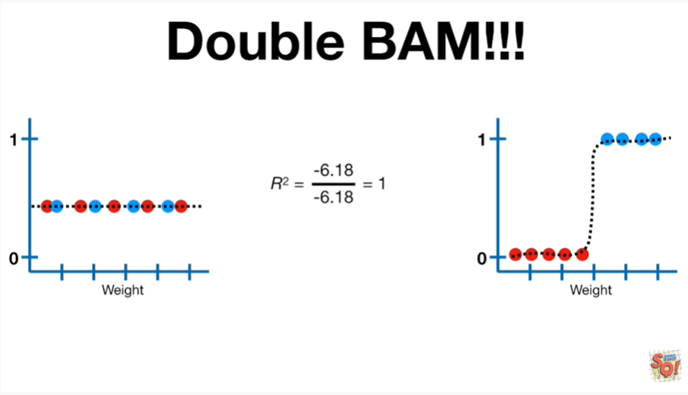

Double BAM !!!

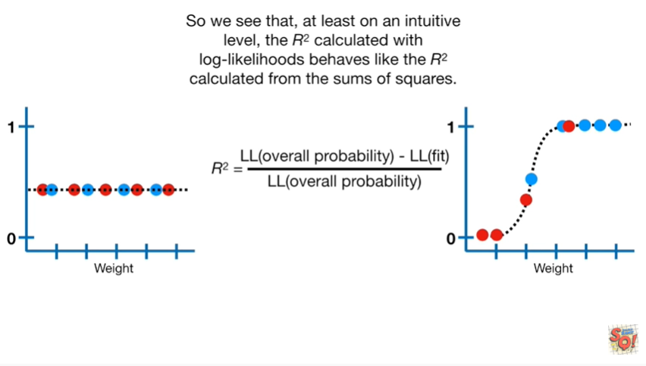

So we see that at least on an intuitive level the r-squared calculated with log likelihoods behaves like the r-squared calculated from sums of squares.

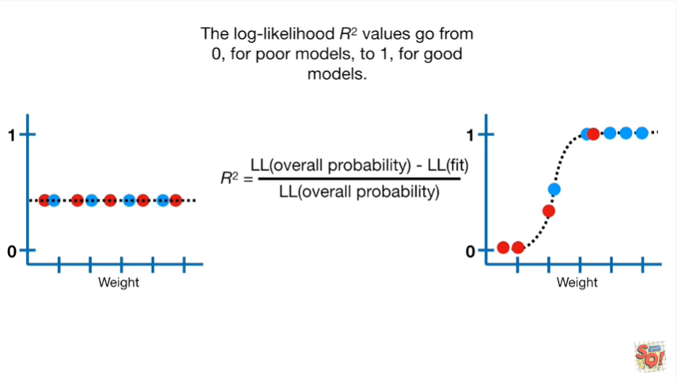

The log likelihood r-squared values go from 0 for poor models to 1 for good models.

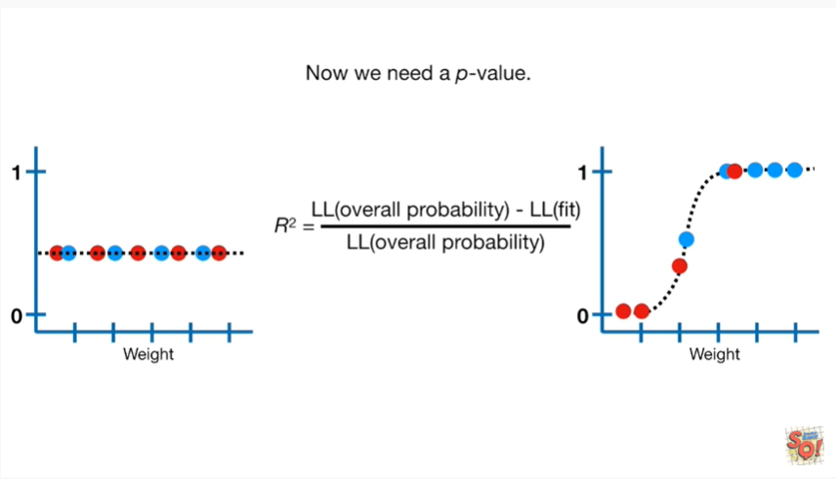

Now we need a p-value.

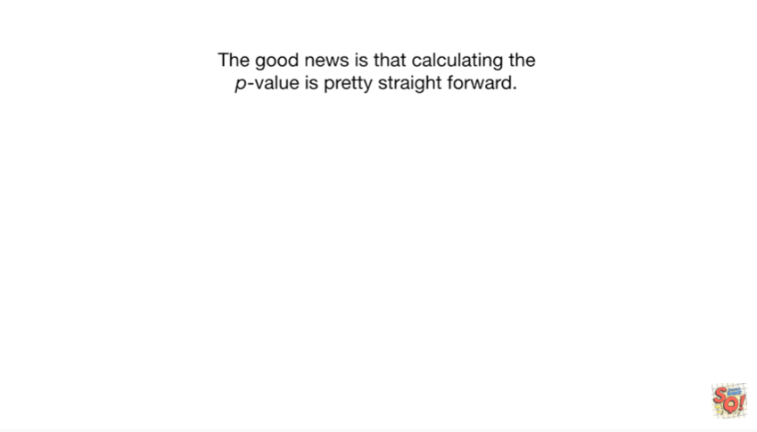

The good news is that calculating the p-value is pretty straightforward.

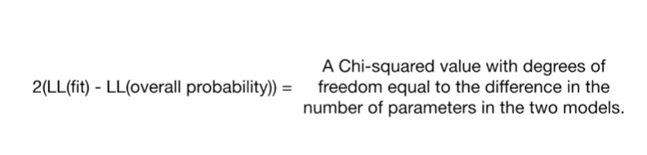

Two times the difference between LL(fit) and LL(overall probability) equals a chi-squared value with degrees freedom equal to the difference in the number of parameters.

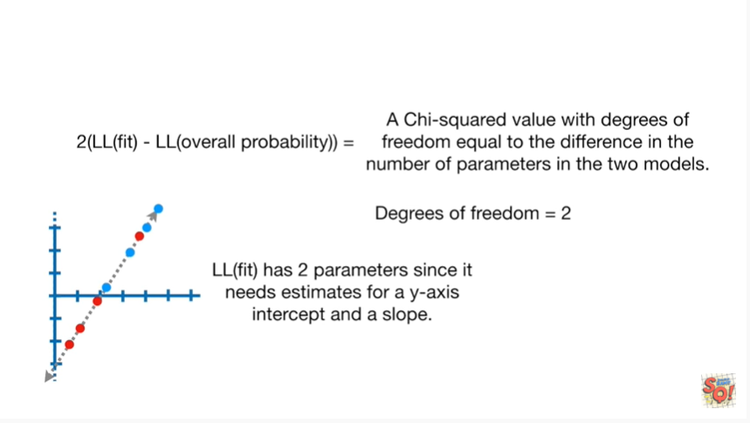

In the two models LL(fit) has two parameters since it needs estimates for a y-axis intercept and a slope.

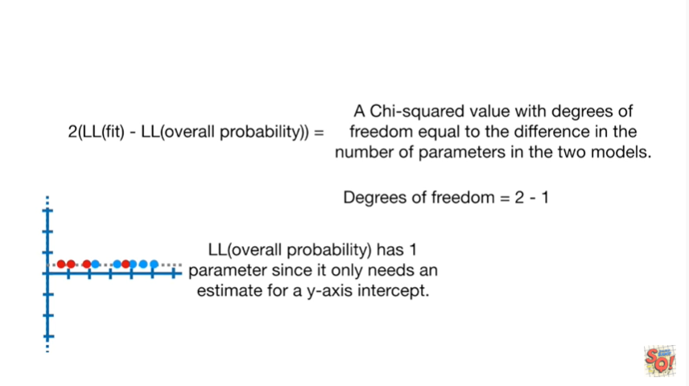

LL(overall probability) has one parameter since it only needs an estimate for a y-axis intercept.

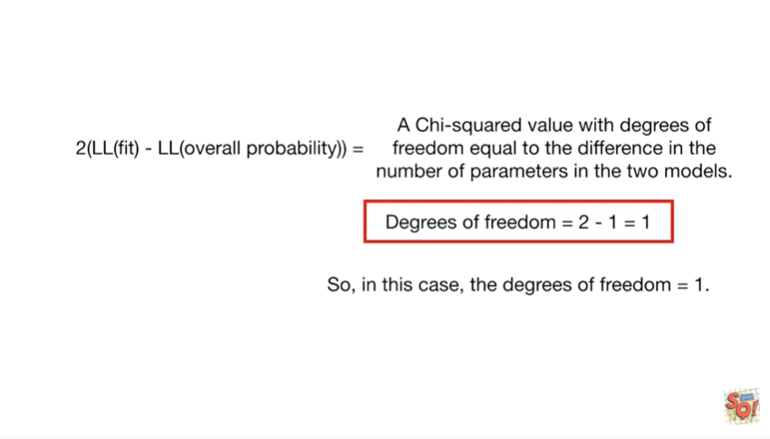

So in this case the degrees of freedom equals 1.

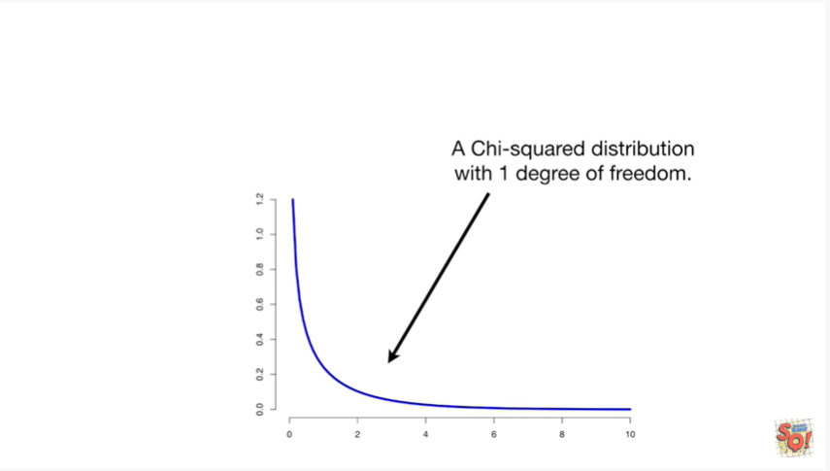

Here's a graph of a chi-squared distribution with one degree of freedom.

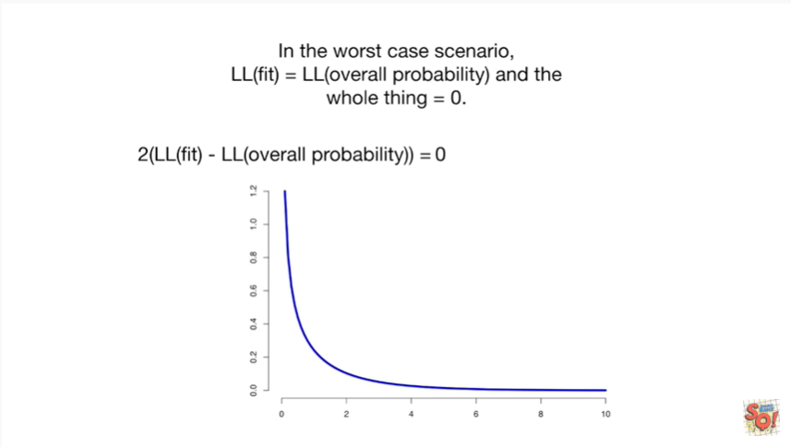

In the worst case scenario LL(fit) equals LL(overall probability) and the whole thing equals zero.

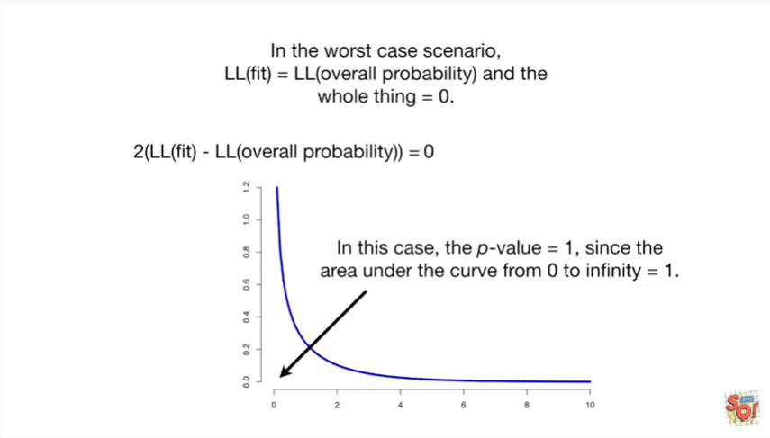

In this case the p value equals one, since the area under the curve from 0 to infinity equals 1.

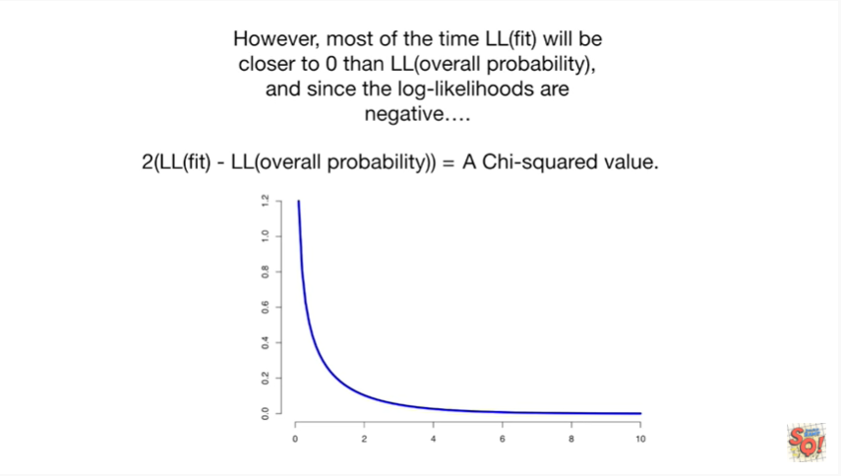

However most of the time LL(fit) will be closer to zero than LL(overall probability) and since the log likelihoods are negative

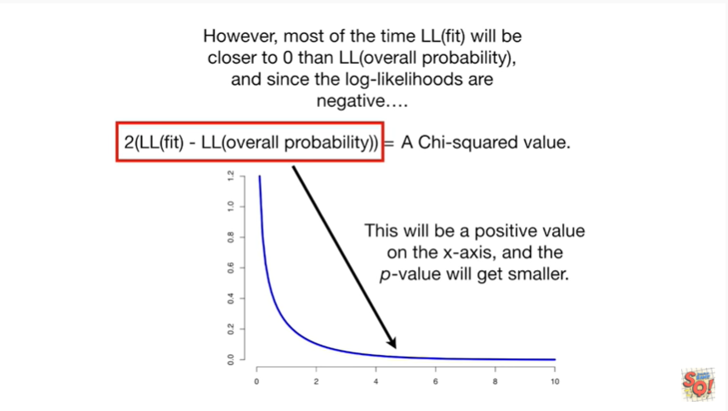

this will be a positive value on the x-axis and the p value will get smaller.

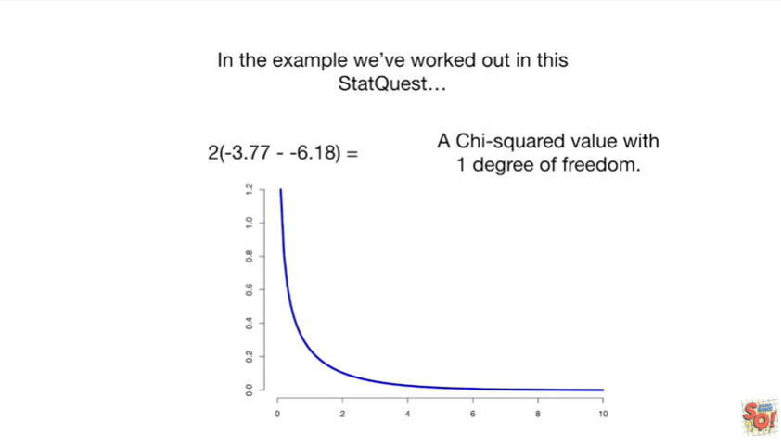

In the example we've worked out in this stat quest

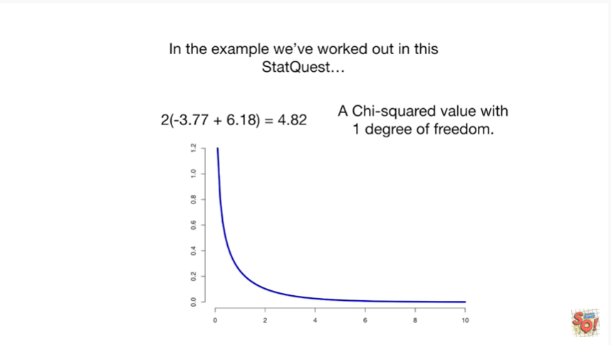

we end up with four point eight two for the chi-squared distribution

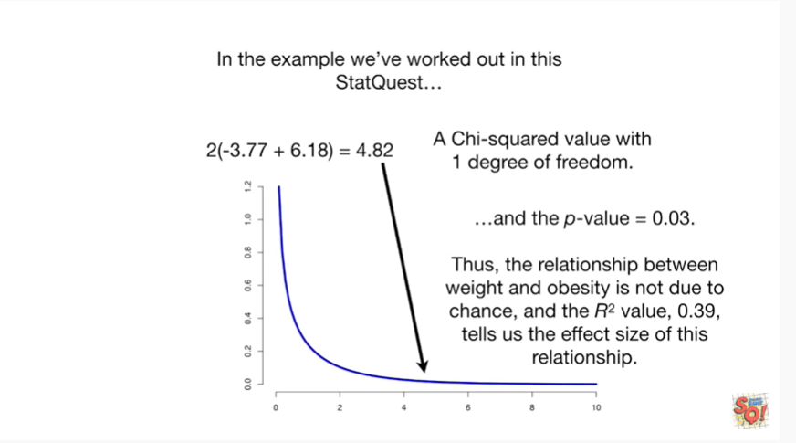

and the p value equals zero point zero three.

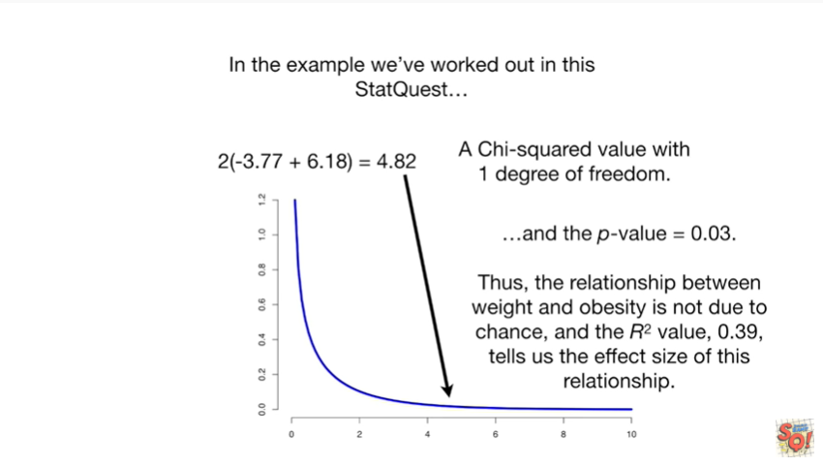

Thus the relationship between weight and obesity is not due to chance and the R squared value zero point three nine tells us the effect size of this relationship.



Triple bam !!!



Before we leave there are a few things I need to point out.

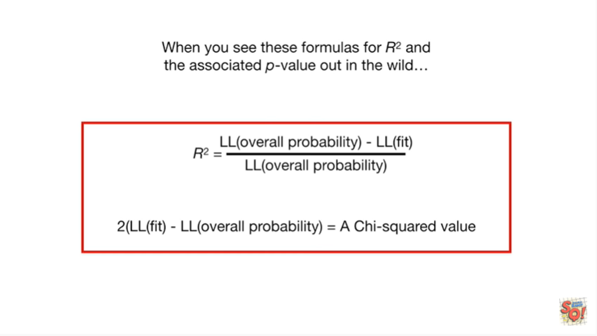

When you see these formulas for r-squared and the associated p-value out in the wild.

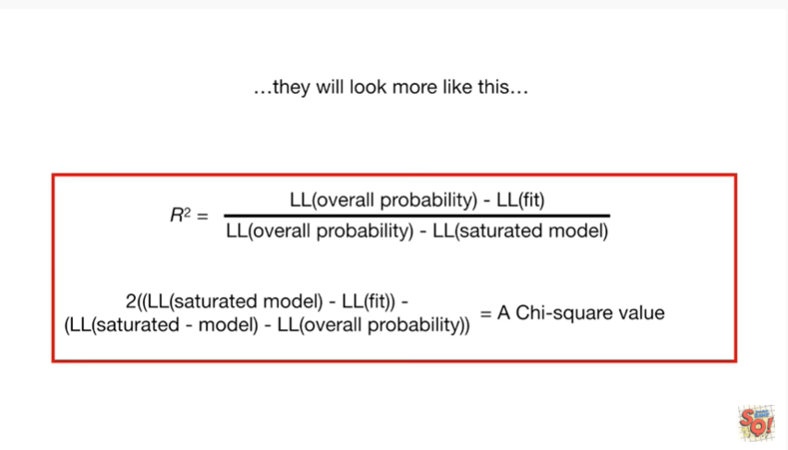

They will look more like this.

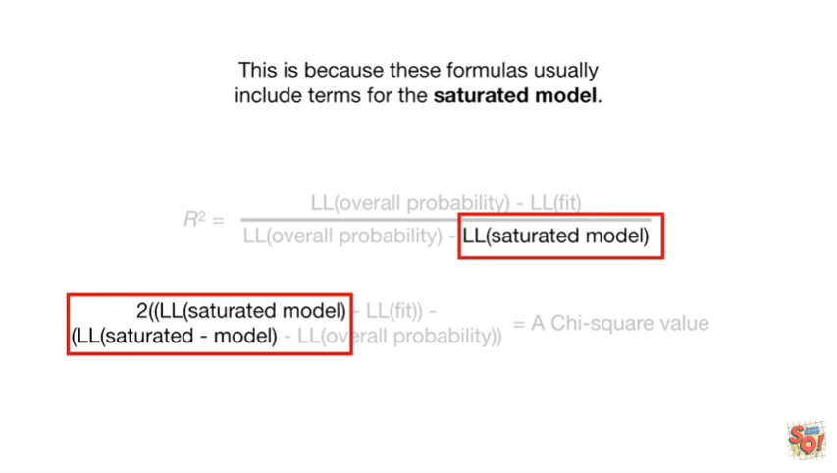

This is because the formulas usually include terms for the saturated model.

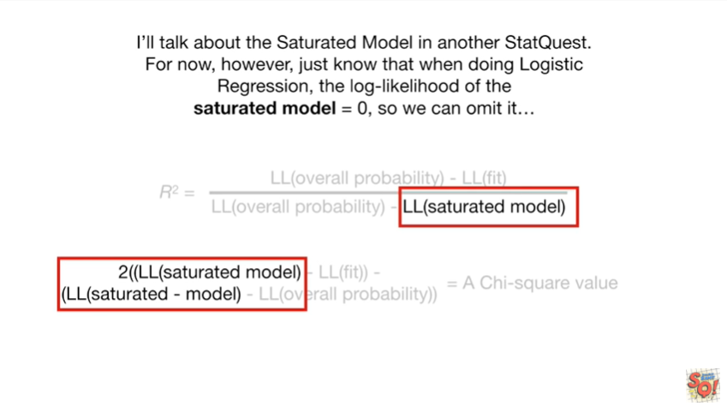

I'll talk more about the saturated model in another stat quest.

For now however just know that when doing logistic regression the log-likelihood of the saturated model equals zero so we can omit it.

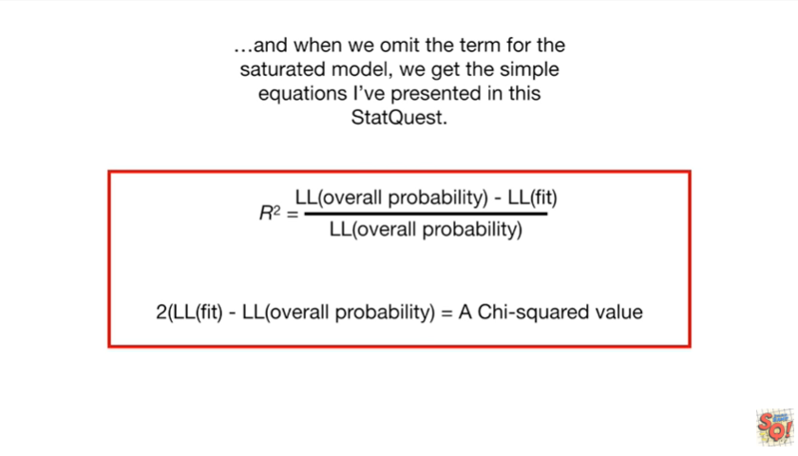

And when we omit the term for the saturated model we get the simple equations are presented in this stat quest.

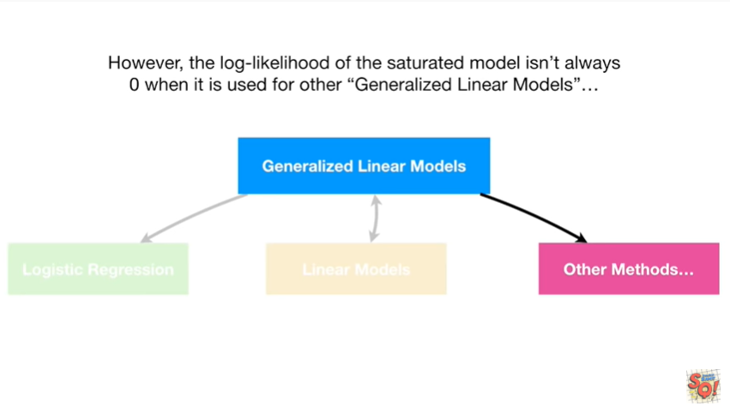

However the log likelihood of the saturated model isn't always zero when it is used with other generalized linear models.

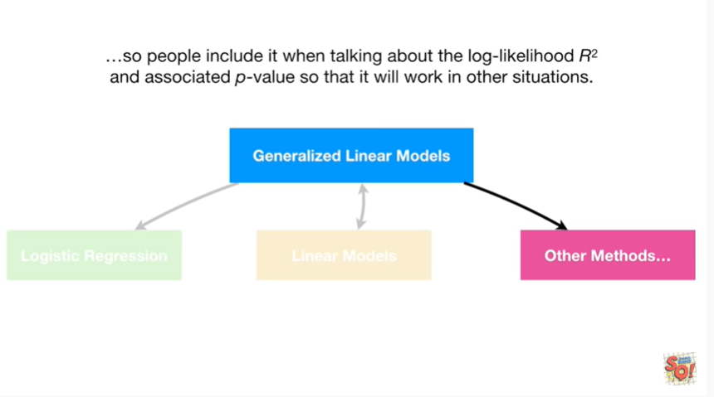

So people included when talking about the log likelihood r-squared and associated p-value so that it'll work in other situations.

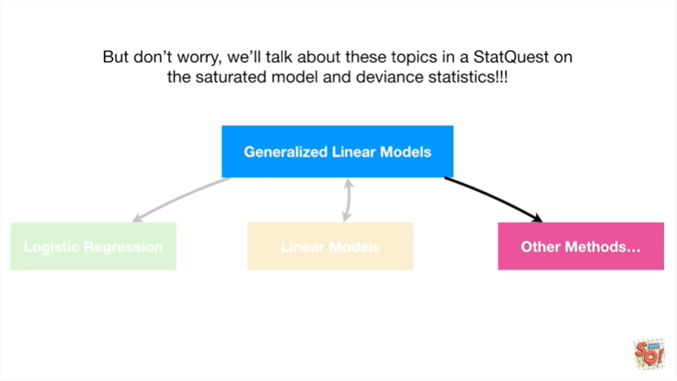

But don't worry we'll talk about these topics in a stat quest on the saturated model and deviance statistics.